**Linwood High School**

Stirling Drive,

Linwood

PA3 3NB

Tel: 0300 300 1333

Children’s Services

**Head Teacher: Gillian Macartney**

Dear Parent/Carer,

The funeral of our pupil William McNally who sadly died on Saturday 5th June, is taking place this Friday morning.

As a mark of respect and to pay tribute to William, our school community has been invited to line the street outside the school as the funeral procession goes past on its journey to Broomward Cemetery in Elderslie.

All staff and pupils will be given the option to take part in this at 10 am however some pupils understandably may wish to stay in school during this time. If you would prefer your son or daughter to not participate on Friday, then please let us know and we will ensure they are looked after. We will also provide support to pupils throughout the day.

Can I also thank pupils and parents who gave such kind donations this week to William’s fund. We have been overwhelmed by the generosity of our school community.

Friday will be a difficult day and all our thoughts continue to be with William’s family and friends.

Yours faithfully

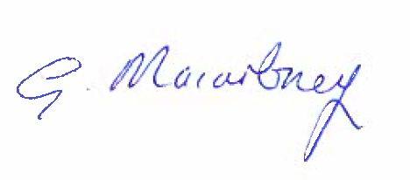

Gillian Macartney