**Linwood High School**

Stirling Drive,

Linwood

PA3 3NB

Tel: 0300 300 1333

**Head Teacher: Gillian Macartney**

Dear Parent/Carer,

Following the Scottish and UK Government directive to close schools from today and cancel exams, I want to update you on the arrangements we are putting in place to support pupils. I am aware that there are uncertainties at this very difficult time, and we will do everything we can to offer ongoing guidance and support for all our young people.

**S4 to S6**

In relation to the national qualifications, from **Tuesday 24th March**, the school will open for S4 to S6 pupils to enable them to complete coursework and to help them achieve their best in their national qualifications. This will be prearranged, and we will be contacting individual pupils offering them advice and the opportunity to attend where possible.

**Children of Key Workers**

Renfrewshire Council is in the process of organising an offer of childcare for the children of key workers only in S1 to S3. Parents have been issued with an online survey to determine who these young people are and is in the process of collating these requests. They will liaise with us about this in due course and would anticipate this being available again from Tuesday 24th March, from 9am to 3pm.

**S1 to S3**

Teaching staff will continue to provide online learning for S1 to S3 pupils and more information on this will follow as soon as possible. Please contact the school if there are any issues regarding accessing internet resources and we will provide hard copies.

I fully appreciate that this is a very worrying time for pupils and parents and please be assured we are working tirelessly to limit the impact on the school community.

This is an unprecedented set of circumstances, so please bear with us and trust that we a planning on a daily basis to have the best support and guidance in place for our pupils.

Please stay safe and well.

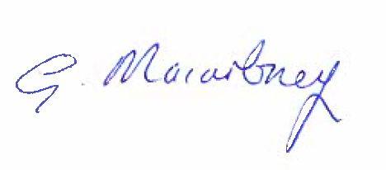

Miss Gillian Macartney

Head Teacher