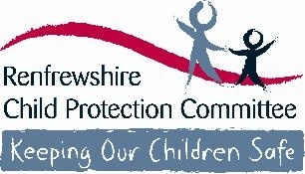

School Name

Linwood High School

Safeguarding and Protecting Children and Young People

Guidance for Session 2023/2024

- Safeguarding includes arrangements for child protection and to ensure wellbeing
- Child Protection means protecting a child from child abuse or neglect
- Abuse or neglect need not have taken place; it is sufficient for a risk assessment to have identified a likelihood or risk of significant harm from abuse or neglect
(National Guidance for Child Protection in Scotland 2014)
The difference between child protection and child abuse could be you

Safeguarding and protecting children and young people is the responsibility of all staff

All Renfrewshire Children’s Services staff and those working in establishments and/or with children and young people must be:

- Aware of arrangements for protecting children
- Alert to children’s needs
- Clear about their own role in ensuring the safety and wellbeing of all children

Our responsibility is to keep children and safe to support and promote their wellbeing by:

- Providing education to children and young people to help them to protect themselves
- Ensuring all staff play a part in the prevention of child abuse and neglect via the curriculum by:
- Raising pupil awareness of risks;
- Developing skills which will help them to keep themselves safe;
- Helping them recognise behaviours in others which may place them at risk; and
- Teaching them how to respond in order to keep themselves safe.

Different Forms of Abuse or Neglect

The following categories of abuse are highlighted within the National Guidance for Child Protection are not exhaustive as individual circumstances of abuse will vary from child to child:

- Physical Abuse – being hit, kicked or punched
- Sexual Abuse – inappropriate sexual behaviour or language by an adult towards a child
- Emotional Abuse – constantly criticised, ignored, humiliated, being subjected to inappropriate expectations
- Neglect –persistent failure to meet a child’s basic or psychological needs: not being properly fed, clothed or cared for or poor hygiene.

All staff should be alert to:

- Unexplained but significant changes to patterns of attendance, presentation or behaviours
- Something the child or young person says, discloses or chooses to confide. Children and young people often take time to build trust and seek out adults to whom they wish to disclose abuse/neglect
- Concerns raised by other children or a third party

Additional areas of concern which you should ensure you are aware of and know the signs to look for:

- Exposure to Domestic Abuse
- Children displaying sexually harmful or problematic behaviours
- Female Genital Mutilation
- Honour based or forced marriages
- Child Trafficking
- Children affected by their parents’ drug or alcohol misuse or mental health issues
- Child Sexual Exploitation
- Children who are at risk through internet use and online behaviour
- Radicalisation – that a young person may be vulnerable to extreme behaviour

What to do if you have a concern:

- Alert the head of establishment or manager designated as responsible for child protection immediately
- Confirm your concern in writing by completing Appendix 3 record of concern alert for staff as soon as possible and give to head or manager. Appendix 3 is attached to this information and additional copies are available (insert where this will be )
- Follow the guidance from head or manager in supporting the child or young person

Responding to Disclosure/Allegations:
- If a child or young person chooses to disclose information about a potential child protection issue to you it is important that you:
- Listen carefully and with your full attention
- Do not guarantee confidentiality – explain that you will have to share this information with the relevant person to keep the child or young person safe
- Do not show disbelief or panic
- Take the allegation seriously and provide reassurance
- Avoid expressing personal views on the matter
- Never seek to investigate by asking leading questions – this is not your role

There should always be a manager responsible for child protection available for you to report your concerns to. In the unlikely event that there is no one available you can contact a local authority manager whose details are at the back of this guidance

CHILD PROTECTION CONTACT LIST
If you have any concerns about a pupil please contact Head Teacher or Child Protection Co-ordinator. If unavailable, the following staff are also responsible for child protection

Head Teacher
Gillian Bowie
Child Protection Co-ordinator
Gillian Bowie

Other school staff with designated responsibility for child protection:
Linda Shaw
Angela Penman
Kirsty Black

Children’s Services Staff

Emma Henry Education Manager 07887 515360
Tracy McGilliveray Head of Education 0141 618 7194
Julie Calder Head of Education 07483 361285

Ensuring wellbeing for all

The Getting it Right for Every Child (GIRFEC) agenda is about ensuring that the wellbeing of all children and young people is the focus for all. It is everyone’s responsibility to understand the wellbeing indicators and to ensure that all our children & young people are:
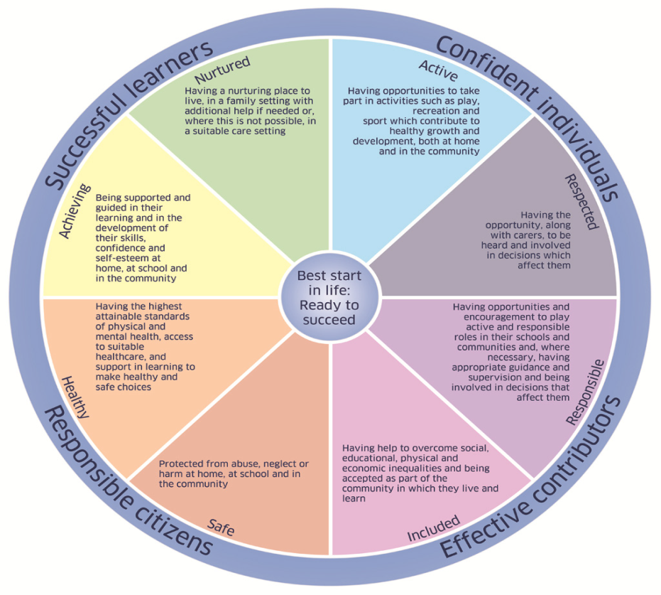
- SAFE
- HEALTHY
- ACTIVE
- NURTURED
- ACHIEVING
- RESPECTED
- RESPONSIBLE
- INCLUDED

More information can be found at:
Renfrewshire Child Protection Committee – www.noworries.org.uk

National Guidance for Child Protection in Scotland www.gov.scot/Publications/2014/05/3052/0
Getting it Right for Every Child
www.gov.scot/Topics/People/Young-People/gettingitright

Children’s Services
Appendix 3
Record of Concern Alert

Please use black ink (or type) and CAPITAL letters.
When you have a concern about a child or young person you must report it immediately to the head or manager. Once you have reported the concern to the head or manager you are required to complete this form on the same day.
Day and date
Head or manager to whom it was reported
Name of child/young person
Establishment/service
Source of Concern (please circle):
Personal Observation | Yes | No
Reported by child | Yes | No
Reported by another source | Yes | No
Please give details of source
Phone call | Yes | No
Please give details of call
Please give details. If a disclosure has been made, record on the back of this form using the child’s own words. SIGN AND DATE DIRECTLY UNDER STATEMENT
Print name
Date and Time
Job Title

