**Linwood High School**

Stirling Drive,

Linwood

PA3 3NB

Tel: 0300 300 1333

Children’s Services

**Head Teacher: Gillian Macartney**

Dear Parent/Carer,

**SQA Provisional Results**

Following the completion of the school assessment period, teachers have been working hard to mark, internally moderate and externally moderate the final pieces of key evidence which will form the basis of the provisional results submitted to the SQA.

I thought it would be useful to outline what you and your child can expect over the next few days.

On Wednesday afternoon, learners will receive a summary of their provisional results for National 5, Higher and Advanced Higher in a letter distributed at the end of the school day. This will allow the pupils to take the letter home and open it in private with their family. Former S6 pupils will be invited to collect the results from the school at 3pm that day.

Included with the results will be a letter explaining how the provisional results were formed and how to appeal to SQA should you wish to do so.

As you are aware, results this year are based on the demonstrated attainment from the key assessment evidence your child has completed. Learners have been kept constantly updated on their progress in these assessments in line with the SQA ACM process.

We wish all our Senior Pupils every success at this important time.

 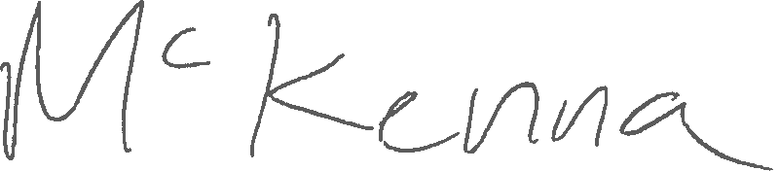

Mr B McKenna

SQA Coordinator