Remote Learning - Parent Information Meeting
Date - 2.2.21 Time - 7pm
To access the meeting you have to log in to your Teams account. On your first page you will see all your teams. You must then go to the box on the top right of this screen and click to join or create a team.

On the second screen go to join team with a code and enter the code sent by text. There will also be a copy of the code on your child’s year group teams page.
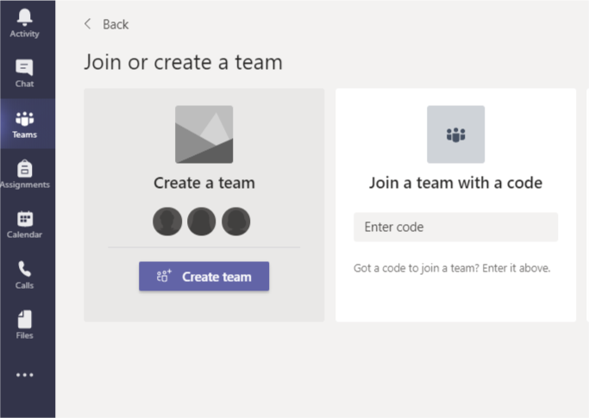

This will give you the option to join the meeting.

