



**Renfrewshire Council Children’s Services**

**Linwood High School**

**Improvement Plan**

**2021-2022**

##### Planning framework

As part of Children’s Services, Linwood High School has developed this establishment improvement plan which provides a framework for how we intend to achieve Children’s Services’ vision of *working together to get it right for children, families, and communities – Protecting, learning, achieving, and nurturing.*

**National Priorities**

We must also take account of the Scottish Government’s national improvement framework which provides a vision for education in Scotland, namely to:

1. **improve attainment, particularly in literacy and numeracy;**
2. **close the attainment gap between the most and least disadvantaged pupils;**
3. **improve children’s health and wellbeing; and**
4. **improve children and young people’s employability skills so that they move into positive and sustained destinations.**

**Renfrewshire’s Education Priorities**

Our priorities will also align with the Renfrewshire Council Plan and Education Improvement Priorities listed on the next page.

**Pupil Equity Funding**

Our school received Pupil Equity Funding (PEF) to provide targeted interventions in literacy, numeracy and health and wellbeing to close the poverty related attainment gap. This funding enables us to plan additional interventions to those which were already planned. These interventions are highlighted throughout this improvement plan using the (PEF) abbreviation.

The priorities and actions within this improvement plan address the needs of our school and articulate with local and national priorities.

**Renfrewshire’s Council Plan 2017-2027**

Working together for a thriving and connected Renfrewshire, creating opportunities for all

Reshaping our place, our economy, our future

Creating a sustainable Renfrewshire for all to enjoy

Building strong, safe and resilient communities

Working together to improve outcomes

Tackling inequality, ensuring opportunities for all

**Renfrewshire Council’s Values**

We are **fair**, we treat each other and everyone we deal with respectfully and work hard to build trust in Renfrewshire Council.

We are **helpful**, we care about getting things right and are always approachable.

We are great **collaborators**; we work as one team and with people who care about this place.

We value **learning** to help us innovate, improve and deliver better services.

**Children’s Services Vision**

Working together to get it right for children, families and communities – protecting, learning, achieving and nurturing

**Renfrewshire’s Education Improvement Plan Priorities**

Reduce inequalities and deliver improved health and wellbeing outcomes for children and young people

Develop high quality leadership to promote empowerment at all levels

Improve employability skills and support all of our young people to enter positive and sustained destinations

Develop high quality learning and teaching that leads to improved levels of attainment and achievement in all of our establishments

**Our Vision, Values and Aims**

Linwood High School is committed to ensuring all young people are **included**, **respected,** and **supported** to thrive in a **safe, nurturing learning environment**. We firmly believe that strong **trusting relationships** and **high expectations** are at the heart of inspiring our young people to achieve and attain both within and beyond school. As a school we recognise the importance of every young person’s **wellbeing** across the whole school community and work with families and partners to ensure successful learning and achievement takes place.

At the core of what we do is the value we place on **respect, care and building positive relationships** which develops **successful, resilient, thriving young people.**

Who did we consult?

To identify our priorities for improvement, we sought the views of staff, pupils, parents, and partners. We used a variety of methods of getting the views of those who are involved in the life and work of Linwood High School such as departmental evaluations, learning evaluations and questionnaires from pupils and staff, parent council meetings. Most of this work was carried out through on-line meetings and email.

We have also consulted with our partners across and out with the Council to assist us in the delivery of our priorities, such as SDS, Developing the Young Workforce, Linwood Community Groups, Home Link, Educational Psychology, Advice Works, Do-Bemindful, identifying strengths and areas of improvements in partnership working.

All information gathered is collated and used to assist us to identify next steps and areas for improvement.

How we will know if we are achieving our aims?

We will measure and evaluate the progress we are making to achieve the key outcomes set out in this plan. We do this using quality assurance activities that include:

* Scheduled one-to-one meetings between SLT and PTs for progress updates
* Quality Improvement Calendars
* Interim written feedback reporting on progress
* Self-evaluation of quality indicators
* Minutes of SLT, ELT and departmental meetings
* Continuous monitoring and tracking of a range of data i.e. Insight, Seemis
* Collegiate group working
* Focus groups of pupils, staff, partners where possible

Each year we also complete a standards and quality report and self-evaluation document which are monitored by Renfrewshire Council Children’s Services’ staff.

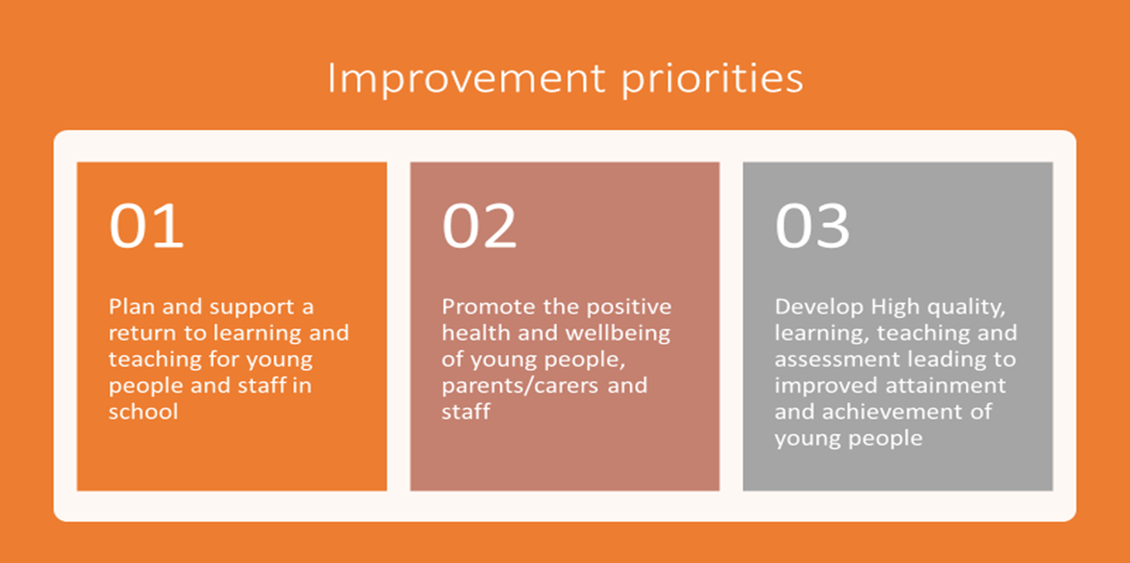

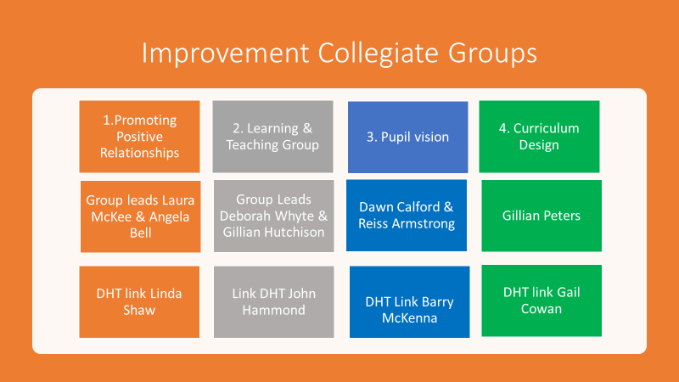

|  |  |  |  |  |
| --- | --- | --- | --- | --- |
| **Improvement Priority 1. Plan and support a return to in-school learning and teaching for all young people and staff** | | | | |
| **HGIOS? QIs**  QIs 1.3-1.5  QIs 2.1-2.4 and 2.6  QI 3.1 | **NIF Priorities**   * Improvement in attainment, particularly in literacy and numeracy * Closing the attainment gap between the most and least disadvantaged children * Improvement in children's and young people’s health and wellbeing * Improvement in employability skills and sustained, positive school leaver destinations for all young people | | **NIF Drivers**   1. School Leadership 4. Assessment of Children’s Progress 2. Teacher Professionalism 5. School Improvement 3. Parental Engagement 6. Performance Information | |
| **Rationale for Change** | **Outcome and Expected Impact** | **Measures** | | **Intervention** |
| Due to periods of lockdown and disrupted in school learning and teaching in session 2020/2021, it is essential to have a recovery plan in place for our young people and staff, in line with local and national guidance.  Should any further level changes mitigations be imposed we want to be well-prepared to ensure that young people and staff can engage in online learning and teaching at home. | By August 2021 staff have increased knowledge of guidelines and expectations when working in school and if required, at home.  By August 2021, all staff, young people, parents/carers will have full knowledge of health and safety measures and will evidence the implementation in their practice. These include hygiene and social distancing measures within the establishment and outdoor areas. All will appreciate the need for regular lateral flow testing and the requirement for PCR testing when required.  By October 2021, all stakeholders will have an increased knowledge of our business continuity arrangements in the event of another lockdown, further mitigations or changes to COVID levels. We have an improved understanding of what would be needed having learned lessons from previous lockdowns. We are well-prepared to provide blended learning, learning at home for all, or for some young people at relatively short notice, should it be required. | All departmental planning will evidence that all teaching and non-teaching staff know and follow the LA Guidance on Remote Learning and the school’s plan for ‘blended’ learning.  Timetables and class groupings reflect the mitigations which were already in place for ‘at least 1m’ social distancing, however where 2m distancing between (i) staff and (ii) staff and pupils is in place, this is retained and clearly evidenced across the school.  Health and Safety workplace assessment and Co-Vid 19 Risk assessments demonstrate that school, local and national guidance is being followed and that a clear and consistent message is shared with staff, young people, and parents/carers. SG version 6.0(03/08/2021) & version 6.1(15/09/2021) are implemented and monitored at school level.  Minutes of departmental/PT meetings show that staff are involved in the health and safety of the school community and in the recovery planning process.    Observations of the internal and external building “flow” will demonstrate that in almost all instances, staff, young people, parents/carers, and visitors are adhering to the health and safety measures in place.  Communication to all stakeholders through digital platforms evidence that clear and consistent messages are being conveyed to all in the school community.  The Business Continuity Plan (BCP) outlines detailed arrangements and actions to be taken (pre, during and post) in the event of a further lockdown/change of level to provide as much educational continuity as possible. | | Adapt **Health and Safety Risk Assessment** to context of Linwood High School using Renfrewshire Council Schools Covid levels guide (latest version updated 15/08/2021) alongside SG Guidance on reducing risk in school’s version 6.0(03/08/2021) & version 6.1 (15/09/2021).  Build upon digital learning, teaching and assessment plans that assesses the wellbeing and learning needs of young people and provides both learning within the establishment and at home. Reinforce positive routines and ensure wellbeing needs are met with daily check ins. All class teachers will follow protocols in place for classroom entrances and exits and practice the good routines laid out in the Learning and Teaching Strategy (2021)  Identify and address staff CLPL needs particularly in relation to digital learning pedagogy and the revised SQA Assessments of National Qualifications. This will be identified through PRD meetings.  Complete and retain the establishment ‘**Business Continuity Plan’**, using the LA template, in consultation with staff and young people.  Communicate and engage fully with parents and the wider community about key messages, protocols, and expectations. This relates to the Guidance on Reducing Risks from COVID-19 in Schools, paying particular attention to;   * Social distancing * Movement of young people * Staggered arrivals, departures, breaks. * Mask wearing * Hygiene and protection * lateral flow testing and requirement of PCR tests and related protocol * Vaccinations * Contact tracing |

|  |  |  |  |  |
| --- | --- | --- | --- | --- |
| **Improvement Priority 2: Promote the positive health and wellbeing of all young people, parents/carers, and staff** | | | | |
| **HGIOS? QIs**  QIs 2.1-2.4  QI 2.7  QI 3.1 | **NIF Priorities**   * Improvement in attainment, particularly in literacy and numeracy * Closing the attainment gap between the most and least disadvantaged children * Improvement in children's and young people’s health and wellbeing * Improvement in employability skills and sustained, positive school leaver destinations for all young people | | **NIF Drivers**   1. School Leadership 4. Assessment of Children’s Progress 2. Teacher Professionalism 5. School Improvement 3. Parental Engagement 6. Performance Information | |
| **Rationale for Change** | **Outcome and Expected Impact** | **Measures** | | **Intervention** |
| Following periods of remote learning and disruption to learning, we recognise the importance of ensuring all young people feel safe and secure about transitioning back to, and beyond school, particularly those at key transition stages and those who are in our vulnerable/targeted groups.  These groups include:   * P7 to S1 * Internal transitions * Vulnerable young people and those with ASN * Young People preparing to leave school to move onto a positive destination.   Re-establishing routines and supporting the health and wellbeing of all young people during this period will be of paramount importance.  Young people have had limited opportunities to feedback “in person” their views on their school experience. Pupil voice and vision is vital currently for recovery to ensure equity and inclusion for all young people.  It is recognised that staff working in our school have all experienced disruption in their working and home environments due to periods of lockdown and remote/interrupted learning. Prioritising staff health and wellbeing will be vital in order to ensure they are in a position to provide the appropriate support to pupils if required.  We recognise the importance of providing clear information to parents/carers and in reassuring parents/carers that their young person will be supported back to, and beyond school. | By December 2021, all staff will have an enhanced knowledge and understanding of programmes, resources, and strategies available to support their own wellbeing.  By October 2021, young people in the target/vulnerable groups will have successfully transitioned and will feel safe, confident, and engaged in their new surroundings.  By October 2021, almost all young people will have increased knowledge and understanding of the supports available to them within school and within the community.  By October 2021, all staff have increased knowledge and understanding of the supports available to support young people’s mental health and wellbeing and draw upon these supports as required.  By March 2022, all young people who are summer/Christmas leavers (2020-2021) have transitioned to a positive destination. Partners in SDS/HE/FE are fully engaged in supporting this process.  By April 2022 all young people will have had the opportunity to provide feedback to the Pupil Vision Collegiate group about their school experience and vison for the future.  All staff and young people will be aware of LGBT inclusive education and guidance for schools on supporting Transgender pupils in schools. | Policies & procedures issued to staff and discussed at meetings, evidence that clear and consistent messages are being provided.  Minutes of departmental meetings show that time is set aside to allow for full discussion of policies & procedures to alleviate any staff concerns.  Participation rates in CLPL and in supports such as Be Mindful show that all staff have engaged in essential training and most staff have participated in optional activities.  Staff self-evaluation as part of the PRD process demonstrates that all staff feel supported and more confident in relation to their own wellbeing.  INSET programme shows that a range of staff wellbeing activities and opportunities are being provided.  Wellbeing health checks carried out by Pupil Support Staff demonstrate that almost all young people are feeling safe at school and/or know where to get help if required.  Departmental planning will demonstrate the increased focus on mental health and wellbeing.  Counselling services’ monitoring and evaluation systems will highlight the positive impact of the service on young people’s mental health and wellbeing.  RNRA gold award will be achieved. Participation in MVR programme will demonstrate a focused approach to supporting families.  Collegiate group will have taken findings from pupil input and How good is OUR school self-evaluation and have a plan in place to implement the results.  Financial Inclusion Pilot scheme will see an increased number of young people accessing FME and EMA as well as those families referred to Advice Works to promote financial inclusion.  School will work towards LGBT School Youth Charter. Staff and pupil evaluations will show a greater understanding of what LGBT inclusion means and looks like within our school community.  Learner conversations will demonstrate that almost all young people know and understand the supports available within school and the community.  Learning visits and departmental evaluations will show that almost all young people are happy in class and engaged in learning.  Statistics show that almost all summer/xmas leavers (2020-2022) have entered a positive destination by March 2022. Careers Advisor appointments show that almost all young people have benefitted from this individual support.  Individualised Learning Plans are updated and minutes of meetings with pupil support show that targeted supports are being discussed with and understood by parents/carers. Pupil support learner conversation inform next steps in HWB supports, and attainment and achievement. Targets set and shared with parents / carers / subject departments.  Communication to parents/carers through virtual meetings, Facebook/Twitter/texts/website and leaflets, demonstrates that clear consistent messages are being provided. | | Plan the collegiate calendar/INSET in collaboration with staff to include dedicated time for staff wellbeing activities. Continue with our health and wellbeing dedicated inset day in May 2022.  Clear channels of communication so that all staff are fully informed of policies & procedures, and arrangements on return. The majority of this will be through email and digitally held.  Health and wellbeing group continue to support wellbeing across the school and  identify additional evidence-based resources/programmes/activities to use to promote staff wellbeing in a nurturing environment. (**led by PEF funded DHT**)  Be mindful programme offered to all staff. (**PEF funded)**  Renfrewshire’s ‘Time for Talking’ for personal support made available if required.  Transition programmes will be delivered in partnership with Primary colleagues and transition teacher. Extended transition  activities will be delivered over the summer for vulnerable young people.  PSE lessons will focus on health and wellbeing activities (mental, emotional, and social, re-establishing routines and supporting experiences in lockdown).  Increased information re: mental health supports available to young people in school and in the community will be stored on shared drive and appropriate signage will be posted around the school. Referral procedures for e.g. The EPS Coping During Co-Vid service and counselling service.  A revised programme of Emotional literacy will be explicitly taught (e.g., RNRA, Seasons for Growth, LLTTF, MVR, mindfulness, art therapy) both within PSE and the Pupil Support Centre.  PSE lessons will have an early focus on mental health and wellbeing. The SQA Mental Health award will be embedded within PSE programmes.  Collegiate group will complete the “whole school values” implementation. Use How Good is OUR School to self-evaluate the pupil experience.  Appointment of Financial Inclusion Lead who will work with Advice Works to promote financial inclusion and support families and young people of Linwood High School.  LGBT staff & pupil group established within the school. All staff undertake LGBT and Transgender inclusive education training.  Counselling service will be established and promoted. Referrals will be made for targeted Young People.  Learning visits (SMT and peer) will focus on health & wellbeing and engagement.  Partners will be identified to enhance delivery of emotional and social education as required.  Pupil support and DYW Lead will work alongside the careers service and partners such as SDS/FE/HE to ensure the summer/xmas leavers receive the support they need to ensure a successful transition post school.  Support with UCAS and college applications will be provided along with input from Focus West.  Transition programmes for targeted P7 children will take place over the summer holiday in small groups.  Activities will be planned for parents/carers including information sessions, Q&A, virtual tours of the building, curriculum overview and practical arrangements for social distancing, hygiene, and new routines.  Individual meetings will be offered to parents/carers of targeted young people with pupil support staff.  Parents are made aware of the range of supports available for young people to help them move on to a positive destination, via digital platforms such as school websites. |

|  |  |  |  |  |
| --- | --- | --- | --- | --- |
| **Improvement Priority 3: Develop high quality, learning, teaching & assessment leading to improved attainment and achievement of young people** | | | | |
| **HGIOS? QIs**  QI 1.2  QIs 2.2 & 2.3  QI 3.2 | **NIF Priorities**   * Improvement in attainment, particularly in literacy and numeracy * Closing the attainment gap between the most and least disadvantaged children * Improvement in children's and young people’s health and wellbeing * Improvement in employability skills and sustained, positive school leaver destinations for all young people | | **NIF Drivers**   1. School Leadership 4. Assessment of Children’s Progress 2. Teacher Professionalism 5. School Improvement 3. Parental Engagement 6. Performance Information | |
| **Rationale for Change** | **Outcome and Expected Impact** | **Measures** | | **Intervention** |
| Following periods of school closures and COVID-19 restrictions we recognise the increased importance of using evidence-based pedagogies in learning and teaching to identify and address gaps in the attainment and achievement of young people.  To ensure improvement in the attainment and achievement for all groups of young people, our senior phase offer must include a wider range of learning experiences leading to improved attainment, achievement, and wider accreditation. | By September 2021 all staff will recognise and effectively use evidence of learning experiences previously collected to inform judgements on all learners’ progress during the period of interrupted learning to plan appropriate revision and next steps in learning.  By September 2021 all staff will use a range of assessment data and evidence-based approaches to raising attainment to support and challenge young people appropriately.  By October 2021, staff will have improved skills and increased confidence in using digital tools to support learning and blended learning if required.  By September 2021 all staff will have identified areas where the ACM model benefitted pupils and will look to incorporate this is in planning for SQA awards in session 2021-22.  Curriculum Design collegiate group will develop a range of models which provide greater opportunities for wider achievement and accreditation. A range of qualifications will be considered, and timetabling options presented to be implemented by session 2022-2023. | Department minutes will reflect discussions around the use of formative assessment to inform appropriately differentiated learning and teaching to meet the needs of individual children.  Attainment and tracking data for almost all young people shows that they are making progress towards agreed target grades. Greater use of “on track” data in BGE to allow for more effective interventions and accurate predictions of learner attainment and achievement pathways.  Informal classroom visits and the monitoring of online/home learning activities will highlight increasing pupil engagement, effective use of digital platforms and independent working skills.  Pupil voice demonstrates that almost all young people can talk confidently about their learning and next steps.  Attainment meetings with staff will demonstrate plans for the ongoing evidence gathering of pupil achievement and attainment. Evidence of assessment and moderation both within and out with the school will demonstrate a robust and consistent approach across all departments.  Departmental meeting minutes will show discussions relating to learning and teaching and sharing good practice.  Increased numbers of young people achieving SCQF level 5 or above qualifications through wider achievement across the curriculum.  Number of young people in the Pupil Support Centre will achieve a greater number of SCQF Level 2/3/4/5 awards from S3 onwards. | | Learning and Teaching collegiate group will update and relaunch learning & teaching strategy. Continuing to lead the dissemination and discussion of evidence-based pedagogies to all staff and provide a forum for highlighting good practice across and out with the school for all departments.  Continue to make skilled use of formative assessment strategies to inform next steps in learning, and access CLPL or professional reading, linked to these approaches, where required e.g.;   * Learning Intentions & Success Criteria * Effective questioning * Feedback * Peer/self-assessment   All departments implement robust and consistent approaches to tracking periods and interventions thereafter. Learner conversations will support this.  As part of the learning and teaching group, Digital Schools Award will be worked towards. Where required, practitioners will access CLPL on digital learning pedagogy to promote  a shared understanding of digital literacy to support teaching and learning.  All departments to consider alternative pathways and course choice in their subject areas in preparation for session 2022-23.  Pupil support centre will increase its curriculum offer to include enterprise and employability, social subjects, outdoor learning, geocaching, geography, photography, administration, personal development **(PEF funded)**.  Literacy, numeracy groups for BGE supported in the Pupil Support Centre and senior buddies **(PEF funded)**. |