Music: National 3

Styles | Melody / Harmony | Rhythm / Tempo | Texture / Structure / Form | Timbre / Dynamics
Blues | Ascending | Accent (Accented) | Unison (Octave) | Striking (Hitting)
Jazz | Descending | Beat (Pulse) in a bar; 2,3,4. | Harmony (Chord) | Blowing
Rock ‘n’ Roll | Step (Stepwise) | On the beat | Solo | Bowing
Musical | Leap (Leaping) | Off the beat | Accompanied | Strumming
Scottish | Repetition | Repetition | Unaccompanied | Plucking
Latin American | Sequence | Slower | Repetition | Orchestra
 | Question and Answer | Faster | Ostinato | Strings
 | Improvisation | Pause | Riff | Brass
 | Chord | March | Round | Woodwind
 | Discord | Reel |  | Untuned Percussion
 | Chord Change | Waltz |  | Tuned Percussion
 |  | Drum Fill |  | Accordion
 |  | Adagio |  | Fiddle
 |  | Allegro |  | Bagpipes
 |  |  |  | Acoustic Guitar
 |  |  |  | Electric Guitar
 |  |  |  | Piano
 |  |  |  | Organ
 |  |  |  | Drum Kit
 |  |  |  | Steel Band
 |  |  |  | Scottish Dance Band
 |  |  |  | Folk Group
 |  |  |  | Voice
 |  |  |  | Choir
 |  |  |  | Staccato
 |  |  |  | Legato

Music Literacy (National 3)

Styles | Melody / Harmony | Rhythm / Tempo | Texture / Structure / Form | Timbre / Dynamics
 | Lines and spaces on the treble clef | Crotchet |  | f - forte
 | Steps | Minim |  | p – piano
 | Repetition | Dotted Minim |  | cresc. - crescendo
 |  | Semi-breve |  | dim. - diminuendo
 |  | Barlines
 |  | Double Barlines

Music: National 4

Styles | Melody / Harmony | Rhythm / Tempo | Texture / Structure / Form | Timbre / Dynamics
Baroque | Major/Minor (Tonality) | Syncopation | Canon | Brass Band
Ragtime | Drone | Scotch Snap | Ternary (ABA) | Wind Band
Romantic | Broken Chord/ Arpeggio | Strathspey | Verse and Chorus | Violin, Cello, Double Bass, Harp
Swing | Chord Progression (Chords I, IV and V in major keys) | Jig | Middle 8 | Flute, Clarinet, Saxophone, Pan Pipes, Recorder
Concerto | Change of Key | Simple Time:  2 3 4  4 4 4 | Theme and Variation | Trumpet, Trombone
Opera | Pedal | Compound Time:  6 9 12  8 8 8 | Cadenza | Timpani, Snare Drum, Bass Drum, Cymbals, Triangle, Tambourine, Guiro, Xylophone, Glockenspiel
Scots Ballads | Scale | Anacrusis | Imitation | Harpsichord
Mouth Music | Pentatonic Scale | Andante |  | Bass Guitar
Reggae | Octave | Accelerando |  | Distortion
African Music | Vamp | Rallentando |  | Muted
Rapping | Scat Singing | A Tempo |  | Soprano, Alto, Tenor Bass
 | Ornament | Dotted Rhythms |  | Backing Vocals

Music Literacy (National 4)

Styles | Melody / Harmony | Rhythm / Tempo | Texture / Structure / Form | Timbre / Dynamics
 | Treble Stave (Middle C – ledger line A) | Semi-Quaver |  | mf – mezzo-forte
 | 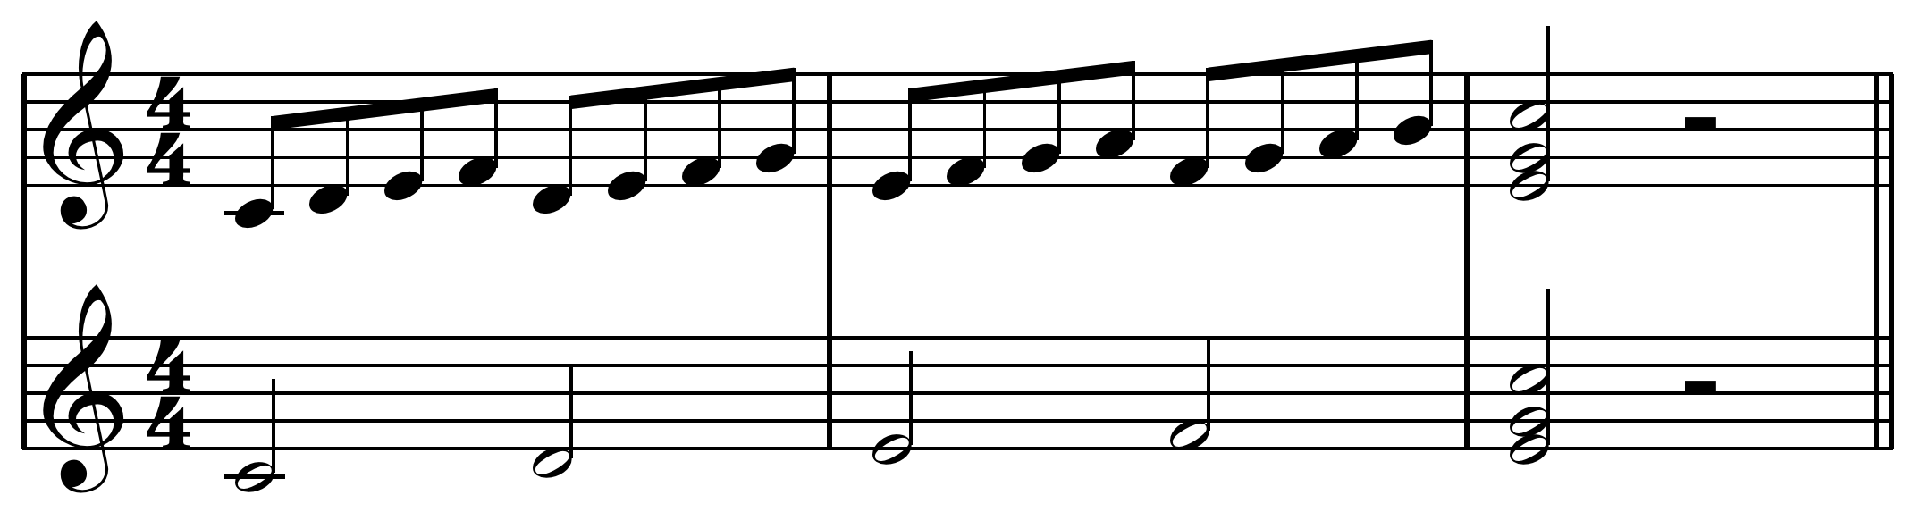  Sequences | Grouped Semi-Quavers |  | mp – mezzo-piano
Paired Semi-Quavers
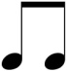

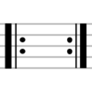
Repeat Signs

Music: National 5

Styles | Melody / Harmony | Rhythm / Tempo | Texture / Structure / Form | Timbre / Dynamics
Symphony | Atonal | Rubato | Strophic | Piccolo
Gospel | Cluster | Ritardando | Binary Form (AB) | Oboe
Classical | Chord Progression (I, IV, V, VI) major | Moderato | Rondo Form (ABACADA) | Bassoon
Pibroch | Imperfect Cadence | Cross Rhythms | Episode | (French) Horn
Celtic Rock | Perfect Cadence | Compound Time:  6 9 12  8 8 8 | Alberti Bass | Tuba
Bothy Ballad | Inverted Pedal |  | Walking Bass | Viola
Waulking Song | Chromatic |  | Ground Bass | Castanets
Gaelic Psalm | Whole-tone Scale |  | Homophonic | Hi-Hat
Aria | Grace Note |  | Polyphonic | Cymbals
Chorus | Glissando |  | Contrapuntal | Bongo
Minimalist | Modulation |  | Coda | Drums
Indian | Contrary Motion |  |  | Clarsach
 | Trill |  |  | Bodhran
 | Syllabic |  |  | Sitar
 | Melismatic |  |  | Tablar
 | Countermelody |  |  | Arco
 | Descant (Voice) |  |  | Pizzicato
 | Pitch Bend |  |  | Con Sordino
 | Tone |  |  | Flutter Tonguing
 | Semitone |  |  | Rolls
 |  |  |  | Reverb
 |  |  |  | Mezzo Soprano
 |  |  |  | Baritone
 |  |  |  | A Capella

Music Literacy (National 5)
Styles | Melody / Harmony | Rhythm / Tempo | Texture / Structure / Form | Timbre / Dynamics
 | Identify tones and semitones | Dotted rhythms |  | ff - fortissimo
 | 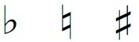  Accidentals | Dotted Crochet |  | pp – pianissimo
 | Scales and Key signatures: C major, G major, F major and A minor | Dotted Quaver |  | sfz - sforzando
 | Chords: C major, G major, F major and A minor | 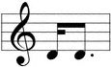  Scotch Snap
 | Leaps | 1st and 2nd time bars

Music: Higher

Styles | Melody / Harmony | Rhythm / Tempo | Texture / Structure / Form | Timbre / Dynamics
Sonata | Mode/Modal | 3 against 2 beats | Through-Composed | Tremolando
Oratorio | Relative Major | Time Changes | Da Capo Aria | Harmonics
Impressionist | Relative Minor | Irregular Time Signatures | Lied | Coloratura
Musique Concrete | Interval | Augmentation | Passacaglia | Ripieno
Plainchant | Obbligato (instrumental) | Diminution | Concerto Grosso - Ritornello | Concertino
Mass | Acciaccatura |  | Sonata Form - Exposition | String Quartet
String Quartet | Mordent |  | Subject
Recitative | Plagal Cadence |  | Basso Continuo
Chamber Music | Interrupted Cadence |  | Ritornello
Jazz Funk | Tierce de Picardie
Soul Music | Dominant 7th Chord
 | Diminished 7th Chord
 | Added 6th Chord
 | Harmonic Minor Scale
 | Melodic Minor Scale

Music Literacy (Higher)

Styles | Melody / Harmony | Rhythm / Tempo | Texture / Structure / Form | Timbre / Dynamics
 | Lines and spaces of Bass Clef (low E to middle C) | Time signature:  6  8 |  | Slurs
 | Note naming and transposing into Bass Clef | Quavers, crochets, dotted crochets, dotted minims |  | 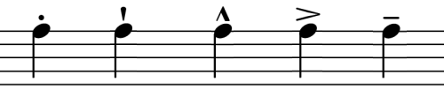  Accents
 | Chords I, IV, V and VI in Major and Minor keys – diminished and dominant | 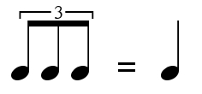  Triplets |  | Staccato marks
 | Naming and writing diatonic intervals formed from Tonic. | Rests: quaver, crochet, dotted crotchet, minim and semibreve |  | Phrase marks
 |  | Da Capo D.C

