**Linwood High School**

Stirling Drive,

Linwood

PA3 3NB

Tel: 0300 300 1333

Children’s Services

**Head Teacher: Gillian Macartney**

Dear Parent/Carer,

On Wednesday 23 June, at the end of the school day, your son/daughter will be given an envelope containing their Provisional SQA results for National 5, Higher and Advanced Higher. These are the grades which we will send to the SQA to provide Senior Pupils with their certificated results on Results Day – 10th August.

The young people of Linwood High School have worked exceptionally hard throughout this year and they have shown dedication and determination during their assessments. We would like to thank them for their effort during this time. We would also like to thank you as parents and carers for your continued support of the school, as well as take this opportunity to reassure you that staff in our school have worked hard to ensure every young person is given the opportunity to give and do their best.

As a school we have confidence in the process of assessment and have confidence in the provisional grades awarded to your child.

All teachers have worked hard to consistently apply the national standards set by SQA to this year’s Alternative Certification Model. Additional quality assurance checks such as validation of all assessments and cross marking has also taken place within and across schools in Renfrewshire to ensure that there has been a robust and fair process to arrive at the provisional grades.

We hope that our pupils are happy with the results that they have achieved. As in any year, some pupils may be disappointed with their results, and as ever, we are here to help in any way we can. Please do not hesitate to contact us if you have any queries at all about your child’s grades, the process we used or the next steps in planning their learning journey.

**National helpline**

Skills Development Scotland have set up a dedicated phone line for any young person who wants to talk about their provisional results. It is open between now and the day before results day (Monday 9th August). Young people can call 0800 917 8000 on Mondays to Friday between 9am and 5pm.

In addition, Skills Development Scotland will have their national results helpline – 0800 100 8000 – open from 10 August at 8am. Further details of all help and support by Skills Development Scotland is available on the My World of Work website.

[www.myworldofwork.co.uk/resultshelpline](http://www.myworldofwork.co.uk/resultshelpline)

**Appeals process**

Pupils across Scotland will have the right to appeal directly to SQA. If your child wishes to register that they want to appeal their provisional result, they do so directly to SQA from the 25th June. Full details of this process can be found on the SQA website,

[www.sqa.org.uk/sqa/79049](http://www.sqa.org.uk/sqa/79049)

At this time, the school are not involved in any appeals and we would ask that you submit any requests directly to the SQA and not the school. You can also visit www.renfrewshire.gov.uk/results for more advice and support.

One again, I would like to thank you for your continued support.

Yours Sincerely,

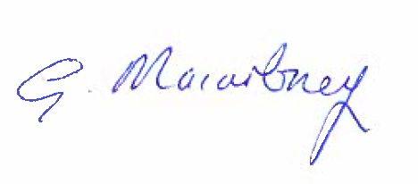

Gillian Macartney