Musical time periods

National Qualifications: Music

Name:_____________________Class________

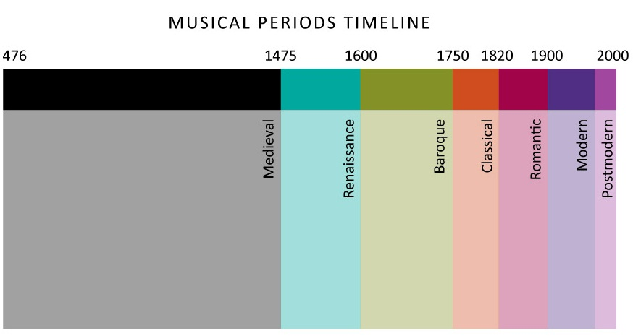

Musical time periods

Starter: What do you already know?

Look at the list of styles below and see if you can match them to the timeline by drawing arrows between the tables

Romantic

Baroque
Minimalism

Classical

20th Century
1850-1900
1750-1830

1600-1750

Baroque

The Baroque period in music comes between 1600 and1750 and can be seen as being highly ornate, lavishly textured and intense.

During this time there was a similar movement in architecture in which lavish decoration was a key factor, resulting in grand castles with ornate decorations, grand staircases and highly decorated grand ballrooms.

Listen to the excerpt of Baroque music and pay careful attention to the sound of the keyboard instrument, the harpsichord.

Harpischord: This is an ancestor of the modern piano in which the strings are plucked rather than struck with a hammer.

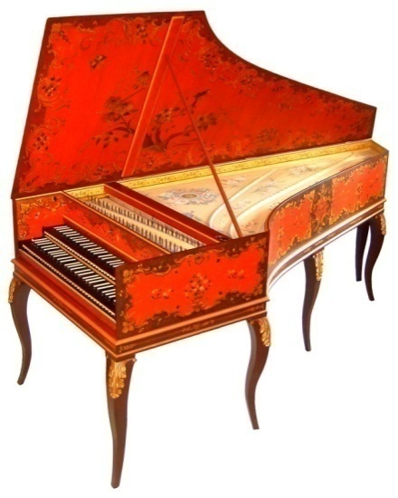

Ornament

These are notes which are added to melodies to decorate them. Music in the Baroque period isfilled with ornaments

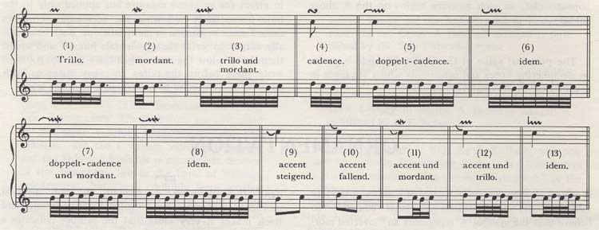

How many ornaments are there in total in this excerpt? ________

Grace note

A grace note is a type of ornament which is a very short note which is added to the start of the main note,
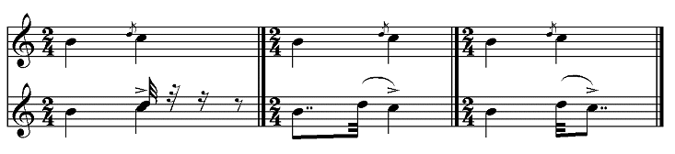
How many grace notes are there? ___________

Play some grace notes on your keyboards now! Make sure you play two notes and that the first note is very short. Try using notes that are close together and notes that are further apart and see which one you like best. Tick a box below.

Close together Further apart

Round

A round is a part song with staggered entries, where each part is the same but begins at a different time, for example “Frere Jaques”. Let’s sing together!

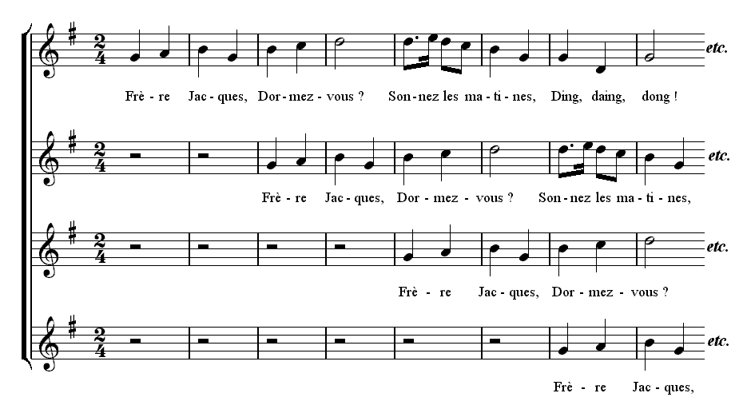
Canon

A form of composition in which all of the parts play the same melody, but begin at different times. A round is a type of canon.

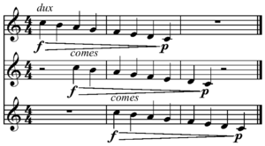

Ground bass

Ground bass is a repeated bass pattern which outlines a chord progression.

Homophonic

This describes the texture of a piece of music. When two or more parts move together in harmony they are homophonic, meaning one voice.

Polyphonic

Polyphonic (meaning ‘many voices’) describes a musical texture in which there are two or more parts moving independently to create the harmony. Parts interweave.

Baroque Listening Revision Exercise

Listen to the following excerpts. Pick one concept from the table to describe what you hear, giving a reason for your answer. Your reason must describe that concept ie

Concepts
Polyphonic Homophonic Ground bass Canon

Grace note Ornament Baroque

- Listen to this excerpt and write down the concept and a reason for your choice below.

Concept | Reason
2

- Listen to this excerpt and write down the concept and a reason for your choice below.

Concept | Reason
2

- Listen to this excerpt and write down the concept and a reason for your choice below.

Concept | Reason

- Listen to this excerpt and write down the concept and a reason for your choice below.

Concept | Reason
2

- Listen to this excerpt and write down the concept and a reason for your choice below.

Concept | Reason
2

- Listen to this excerpt and write down the concept and a reason for your choice below.

Concept | Reason
2

Musical time periods homework

Using the following website revise all of the concepts you’ve learnt today.

http://www.atae.co.uk

Tick them off here as you listen to each example, and write down the website’s definition in the space provided.

Baroque ______________________________________

Ornament ______________________________________

Grace note ______________________________________

Canon ______________________________________

Ground bass ______________________________________

Homophonic ______________________________________

Polyphonic ______________________________________

Harpsichord _____________________________________

The Classical period and form

Classical

Music composed during the period 1750-1810 approximately; the era of Haydn, Mozart and Beethoven.

Harmony is relatively simple compared to the dense harmonic structures of the baroque period, and the music contains fewer ornaments and is ‘lighter’ sounding.

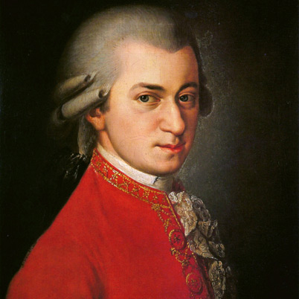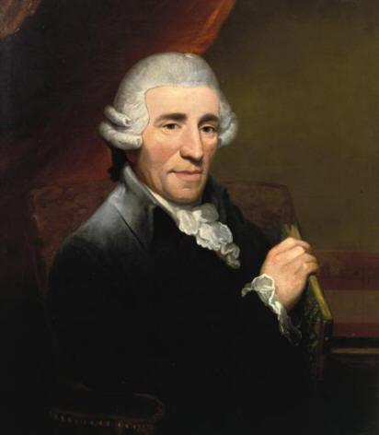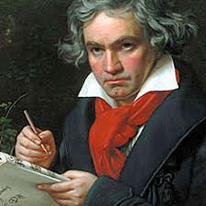
Mozart Haydn Beethoven

Symphony

A symphony is a large work for orchestra, usually in four movements.

Concerto

A concerto is a large scale piece of music for solo instrument and orchestra. Concertos normally have three sections or movements.

Concerto or Symphony?

Listen to the following examples and tick the correct box.

- This is an excerpt from a

Symphony Concerto

If concerto name the solo instrument: __________________

- This is an excerpt from a

Symphony Concerto

If concerto name the solo instrument: __________________

- This is an excerpt from a

Symphony Concerto

If concerto name the solo instrument: __________________

- This is an excerpt from a

Symphony Concerto

If concerto name the solo instrument: __________________

- This is an excerpt from a

Symphony Concerto

If concerto name the solo instrument: __________________

Form

Form is how music is structured. Music can be structured in many ways, the following are just a few of them.

Ternary form (ABA)

The music has three distinct sections. The main melody (A) followed by a second melody (B) and the return of the main melody (A).

This is ‘Twinkle twinkle little star’. Play it now on your keyboards.

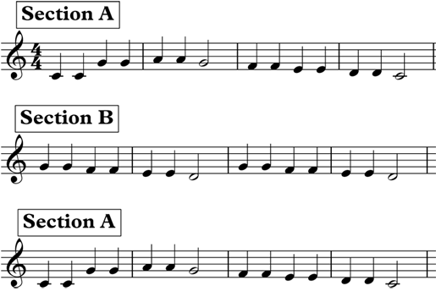

Theme and variations

Theme and variations is a musical form in which the melody is stated and then repeated with a series of variations. The variations can be rhythmic, harmonic or melodic.
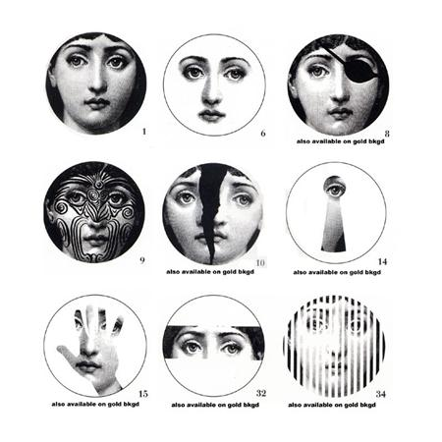

All of the photographs above are derived from the very first one. This is how a theme and variations can look in the art world.

Rondo form

A form where the first section (A) keeps returning, in between different sections, for example ABACADAE etc…

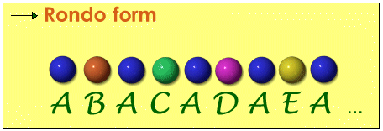

Coda

Coda, Italian for tail, is a small section at the end of a piece of music or which looks back over the music played and brings it to a close.

How well have you been listening?

Your aim is to score full marks!!!!

- This question is about different styles of music.

- Tick one box to describe what you hear:

Symphony

Concerto

Baroque

- Listen to that excerpt again and identify the form of the piece:

________________________________________

- As you listen to this excerpt you are asked to identify the prominent features of the music.

In your answer, comment on at least three of the following:

  - Melody/harmony

  - Rhythm/tempo

  - Instruments/voices

  - Dynamics (Italian terms)

You will hear the music three times, with a pause of 2 minutes at the end for you to complete your final answer.

Here is the music for the first time.
Here is the music for the second time.
Here is the music for the third time.

Melody/harmony

Rhythm/tempo
Instruments/voices and how they are used

Dynamics

- In this question you will hear an excerpt of music which will be played three times.

Tick one answer only in each of the three sections:

Tonality
Rhythm/Tempo
Timbre

Here is this excerpt for the first time.
Here is the excerpt for the second time.
Here is the excerpt for the third time.

Tonality | Major
 | Minor
 | Atonal
Rhythm/Tempo | 4 Beats Per Bar
 | 3 Beats per Bar
Timbre | Piano
 | Orchestra
 | Harpsichord

Alberti Bass

Used often in the classical period as an accompaniment figure for piano pieces. Broken chords are played by the left hand outlining harmonies whilst the right hand plays the melody.

Alberti bass task

Look at the music below. The top stave is playing the melody and the bottom stave is accompanying with an Alberti Bass.

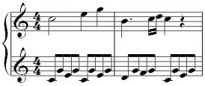

Your task is to write out an alberti bass using the chords below. Try to keep all the notes as close together as possible. Look at the example given for a different set of chords to guide you.

Chord | Notes
C major | C, E, G
A minor | A, C, E
D minor | D, F, A
G major | G, B, D

Example 1
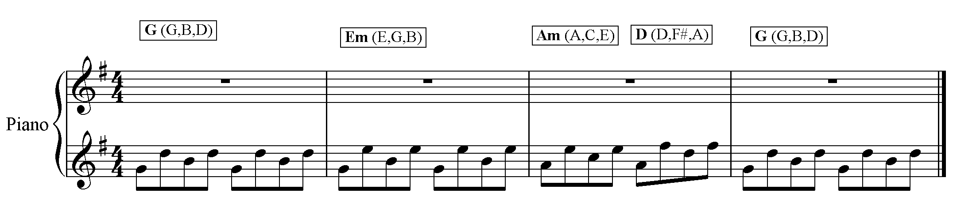

Alberti bass task

Ok, so how did we do that and what do we need to know?

Well, you need to know the notes of the treble clef….
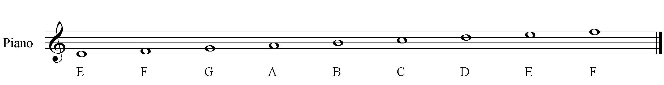

Next you need to know that you are writing all quavers and grouping them into fours…
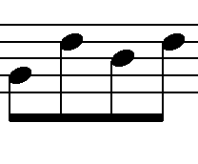
(Notice that when the noteheads are above the 3rd line of the stave the stems go down)

In the example above, the notes are G, D, B, D, spelling out the chord of G major. Note that you can start on any note, as long as you keep the same basic shape as in Example 1.

Go ahead and write out your alberti bass for the example below. Write in the second stave only.

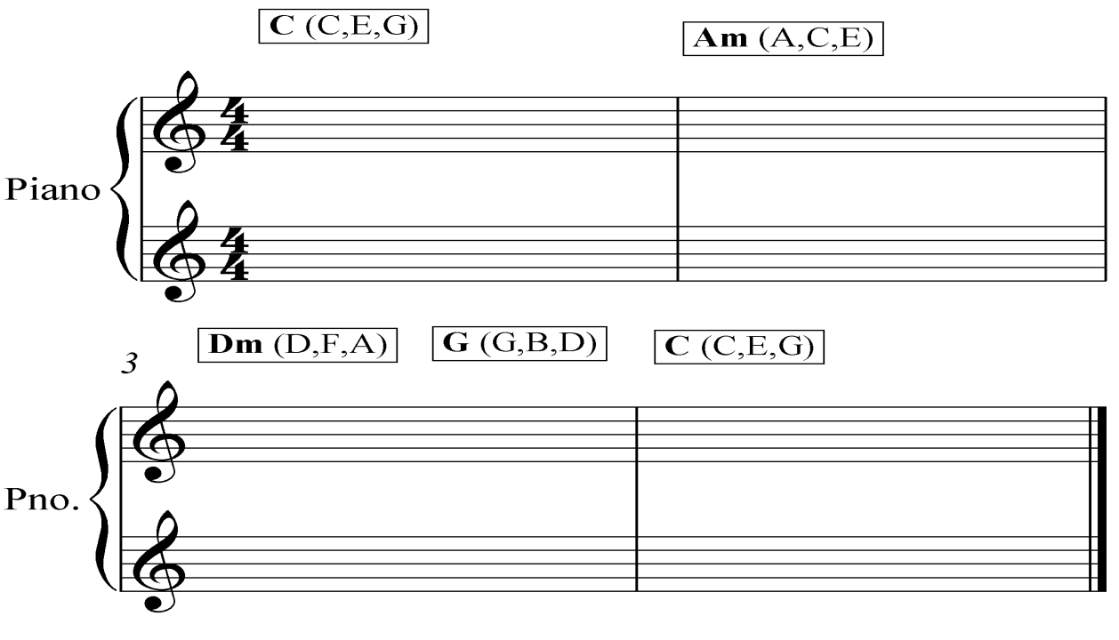
Musical time periods homework 2

Using the following website revise all of the concepts you’ve learnt today.

http://www.atae.co.uk

Tick them off here as you listen to each example, and write down the website’s definition in the space provided.

Classical ______________________________________

Symphony ______________________________________

Concerto ______________________________________

Alberti bass ______________________________________

Ternary ______________________________________

Theme and variations _ ___________________________________

Polyphonic ______________________________________

Romantic

The Romantic period falls between 1810 and 1900 approximately, following on from the Classical period.

Harmony becomes more complex, the orchestra larger, and the music becomes more expressive in general.

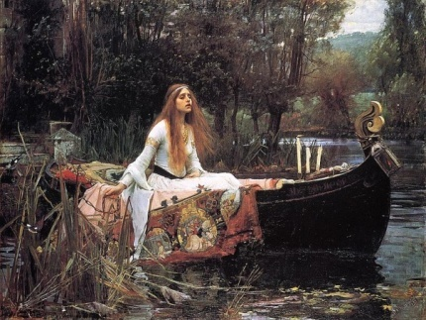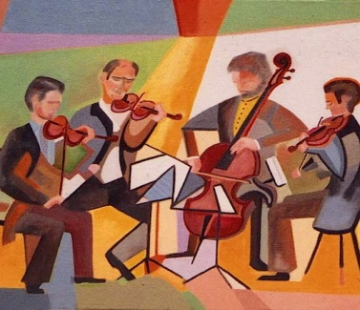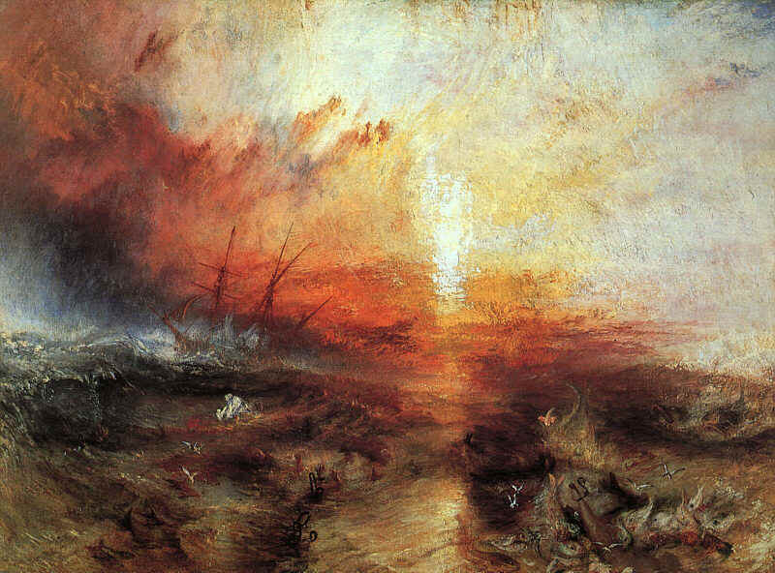

Whole tone scale

A six note scale which moves by whole tones. Used by romantic composers such as Debussy and Dvorak, and in the 20th century by Jazz musicians and film composers.

Chromatic scale

A scale which moves by semitones.

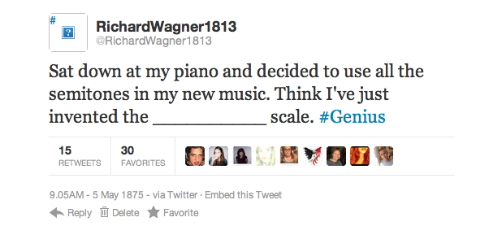
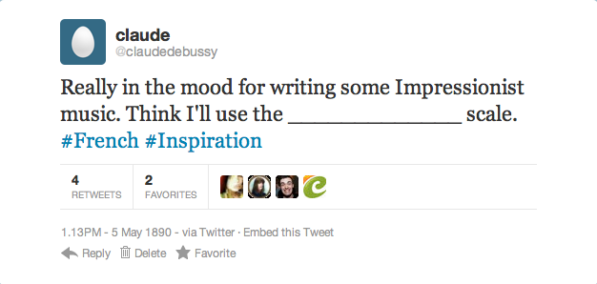

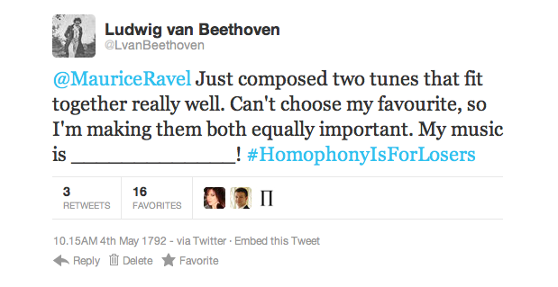

Musical time periods homework 3

Using the following website revise all of the concepts you’ve learnt today.

http://www.atae.co.uk

Tick them off here as you listen to each example, and write down the website’s definition in the space provided.

Romantic ______________________________________

Whole tone ______________________________________

Chromatic ______________________________________

Adagio ______________________________________

Andante ______________________________________

Allegro ______________________________________

Accelerando ______________________________________

Rallentando ______________________________________

A tempo ______________________________________

Pause ____________________________________

Name:
Class:
20th Century
1. __________ music does not have a home key. It is not ________ or ________.

2. A ________ is when notes that are very close to each other are played together to create a clashing harmony.
3. _______________ is a form of composition where simple rhythmic and melodic features are constantly repeated with very slight changes each time.
Major Cluster Minimalism
Minor Atonal

Steve Reich – Clapping Music

Tempo

Musical time periods homework 4

Using the following website revise all of the concepts you’ve learned today.

http://www.atae.co.uk

Minimalism ______________________________________

Atonal ______________________________________

Cluster ______________________________________

Adagio ______________________________________

Andante ______________________________________

Allegro ______________________________________

Accelerando ______________________________________

Rallentando ______________________________________

A tempo ______________________________________

Pause ____________________________________

Revision and end of unit assessment.

Revise all the concepts in this booklet, ticking them off once you feel sure you know them. Make a note of the type of concept it is ie melodic, style, texture etc.

Baroque ______________________________________

Ornament ______________________________________

Grace note ______________________________________

Canon ______________________________________

Ground bass ______________________________________

Homophonic ______________________________________

Polyphonic ______________________________________

Harpsichord _____________________________________

Classical ______________________________________

Symphony ______________________________________

Concerto ______________________________________

Alberti bass ______________________________________

Ternary ______________________________________

Theme and variations _ ___________________________________

Polyphonic ______________________________________

Romantic ______________________________________

Whole tone ______________________________________

Chromatic ______________________________________

Adagio ______________________________________

Andante ______________________________________

Allegro ______________________________________

Accelerando ______________________________________

Rallentando ______________________________________

A tempo ______________________________________

Pause ____________________________________

Minimalism ______________________________________

Atonal ______________________________________

Cluster ______________________________________

Adagio ______________________________________

Andante ______________________________________

Allegro ______________________________________

Accelerando ______________________________________

Rallentando ______________________________________

A tempo ______________________________________

Pause ____________________________________

