S1 Close Reading:
Homework Booklet

Fiction and Non-Fiction


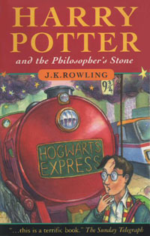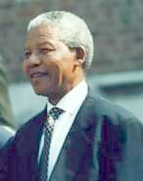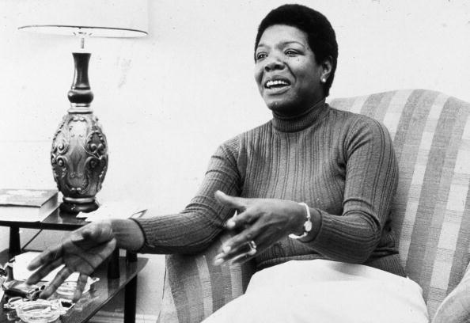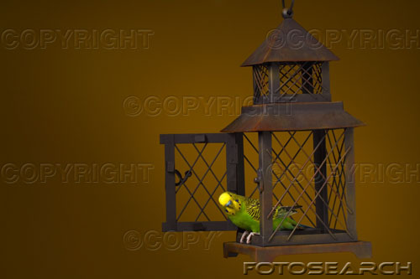

- Through developing my knowledge of context clues, punctuation, grammar and layout, I can read unfamiliar texts with increasing fluency, understanding and expression. ENG 3-12a

- To show my understanding, I can comment, with evidence on the content and form of short extended texts, and respond to literal, inferential and evaluative questions and other types of close reading tasks. ENG 3-17a

- I can read and interpret unfamiliar texts with increasing fluency and understanding.

- I can understand texts and can answer a variety of different types of questions on them.

Question Types

The types of questions you will be asked will depend on the skill that is being assessed:
- Understanding
- Analysis

Checklist of Questions
In order to answer these questions you must first understand what the question requires you to do. You should refer back to this checklist to remind yourself what different questions require you to do.

Understanding
These questions are checking how well you have understood the passage. You must read both the question and the relevant section of the passage very carefully.

Answer in your own words
In order to answer this type of question you need to go back to the passage and find the correct sentence that you have been asked to put into your own words. Then pick out the key words from the sentence. Then try to change these key words into your own words.

- Pick out an expression or a phrase
This type of question is testing you on two things. The first thing it is testing you on is do you know what an expression is. The second thing is can you pick out the correct expression. An expression or a phrase is a few words taken directly from the passage.

- Pick out one word from the passage
This type of question is again testing you on two things. The first thing is how carefully you have read the question and realise that it is only one word that you have to pick out. The second thing is can you pick out the correct word.

- True, False or Can’t Tell
This type of question is testing you on how closely you have read the passage. If you have read it closely you should be able to say if something is true, false or if you can’t tell from the passage.
True – If something is true then it will say it clearly in the passage.
False – If something is false it will say something different.
Can’t Tell – If you can’t tell then it doesn’t mention it at all in the passage or it doesn’t give you enough information about it.

Analysis

These questions are checking your knowledge of language (techniques) and might ask you to comment on how these are used by the writer.

- Comment on a technique (sentence structure/figurative language/ tone)

Sentence Structure
This type of question is asking you to look at how a sentence has been written, not what the sentence means. In order to answer this type of question you have to look at a number of things.

(a)The length of the sentences.
Is there one big long sentence? If so think about why it might be used. It could be used to show the size or length of something or it could show that a lot of things are happening quickly.
Are there lots of short sentences? If so why have they been used? Sometimes short sentences can be used to create tension or suspense. Or they can be used to show that something is very short and does not take a lot of time.

(b) Punctuation

- Another thing that you have to think about is the punctuation that is used. Are there lots of commas, exclamation marks or question marks? Or are there brackets used? You have to identify the punctuation and then say why you think it has been used.

The full stop. This is used to show that it is the end of a sentence.
The comma, This is used to divide words on a list.
The exclamation mark! This is used to show that someone is speaking loudly because they are angry, excited, shocked or happy.
The question mark? This is used to show that a question has been asked.
Brackets () These are used to give extra information.

Direct speech marks
or quotation marks “ “ These are used to show that someone is speaking or because there is a quotation from someone.

(c) Repetition: This is simply when the writer repeats a word or phrase. This is usually done to draw attention to something.

Figurative Language

Figurative language is language that uses words or expressions with a meaning that is different from the literal interpretation.

- Imagery

Simile: This is when the writer compares two things using like or as, for example ‘The night sky was as black as ink.’
Metaphor: This is when the writer compares two things without using like or as. Instead they just say that the first thing is the second thing. ‘The man was a mountain.’
Personification: This is a type of metaphor that makes objects sound as if they are alive. ‘The angry sea swept the boat towards the rocks.’

- Sound devices

Alliteration: This is when words in a sentence start with the same sound, for example Tetley teabags tingle taste buds. The repetition of the t sound is called alliteration. Often alliteration is used in newspaper headlines to create an eye-catching headline.
Onomatopoeia: This is when words imitate the sound they describe, for example: crash, smash, bang, whimper…

Tone – Sometimes you might be asked to pick out the tone of a passage or of something that someone says. When you are asked about tone, try to imagine someone speaking the lines and the tone of voice they might use: Common tones are: happy, sad, sympathetic, hurtful, doubtful, fearful, sarcastic, humorous, angry, ironic…

Your passages are divided into two sections:
- Fiction – Fiction is usually stories made up by the author.
- Non-Fiction – Non-Fiction is based on fact, things that have actually happened.

Section A – Fiction

Contents Page:

Exercise One: Red Sky in the Morning
Exercise Two: Room 13
Exercise Three: Artemis Fowl
Exercise Four: Carrie’s War
Exercise Five: The Tulip Touch
Exercise Six: Harry Potter
Exercise Seven: Underground to Canada
Exercise Eight: Gowie Corby Plays Chicken
Exercise Nine: Coraline
Exercise Ten: Whispers in the Graveyard

Section B – Non-Fiction
Contents Page:

Exercise Eleven: The Diary of Anne Frank
Exercise Twelve: Great White Sharks
Exercise Thirteen: Votes for Women
Exercise Fourteen: Surviving Hitler
Exercise Fifteen: Chinese Cinderella
Exercise Sixteen: Long Walk to Freedom
Exercise Seventeen: Wild Swans
Exercise Eighteen: I Know Why the Caged Bird Sings
Exercise Nineteen: Letter from Hawaii
Exercise Twenty: I Know Why the Caged Bird Sings


Exercise One
Below is an extract from ‘Red Sky in the Morning’. It describes how the main character Anna feels the morning after the birth of her handicapped brother Ben.

I felt pretty funny going to school the next morning, partly because I was completely exhausted, I suppose. Dad said I could stay at home if I liked. He’d got the week off work. But I wanted to go. One reason was to get out of the house, because there was an awfully gloomy atmosphere, and Mum cried a lot, and Dad was on the phone all the time. Katy was a pest too. She’d got it into her head to be all fluffy, and sugar sweet, and babyish, and I could have kicked her.
The other reason was that I was bursting to tell everyone at school. It’s not often that I have some real news. Not like Sandra, whose older brother is in the Marines, or Miranda, who goes to masses of discos, and does things with boys. Actually, I’m not all that popular at school. I used to be best friends with Debbie, ages ago, and that was fine, because everyone likes her, so they let me into their group too.
Debbie’s one of the most beautiful people I’ve ever seen. She’s got this wonderful deep chestnut hair that she can flick about her face and it falls back into place, like on the shampoo ads. And she’s got a long, finely chiselled nose, and perfectly even teeth, and transparent skin covered with a sort of bloom, like a peach, and huge luscious eyes that are big and brown like a spaniel’s.

Questions
(1) In your own words explain why Anna wants to get out of the house. (1)
(2) Pick out an expression that tells you that Anna is annoyed at her sister, Katy. (1)
(3) Anna felt funny going to school because she was A) happy B) angry C) tired. Give a reason for your answer. (2)
(4) Pick out one word, which tells you that Anna looked forward to sharing her news. (1)
(5)Pick out 5 things that Anna admires about Debbie. (5)
(6a)Pick out an example of a simile from the passage. (1)
(6b)Explain why you think it is effective. (2)
(7)Find out what the words: ‘transparent’, ‘chiselled’ and ‘luscious’ mean. (3)


Exercise Two
Below is an extract from ‘Room 13’. In this extract one of the main characters Fliss describes a dream she has the night before she goes on a school trip to Whitby.

This is what Fliss dreamed the night before Year 7 went to Whitby.
She was walking on a road high above the sea. It was dark. She was alone. Waves were breaking at the foot of cliffs to her left, and further out, the moonlight made a silver path on the water.
In front of her was a house. It was a tall house, looming blackly against the sky. There were many windows, all of them dark.
Fliss was afraid. She didn’t want to go inside the house. She didn’t even want to walk past but she has no control over her feet. They seemed to go by themselves, forcing her on.
She came to a gate. It was made of iron, worked into curly patterns. Near the top was a bit that was supposed to be a bird in flight – a seagull perhaps- but the gate had been painted black, and the paint had run and hardened into little stalactites along the bird’s wings, making it look like a bat.

Questions
(1) Look at paragraph two. What do you notice about the length of some of the sentences? Explain why you think they have been written like this. (2)
(2a) Pick out an example of a metaphor from paragraph two. (1)
(2b) Explain why you think it is effective. (2)
(3) In your own words describe what the house that Fliss sees looks like. (2)
(4) Pick out an expression that shows that Fliss could not stop herself from going towards the house even though she did not want to. (1)
(5a) What are your first impressions of the house? (1)
(5b) Give a reason for your answer. (2)
(6) Find out the meaning of ‘stalactites’. (1)

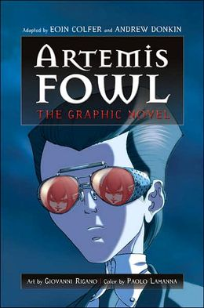
Exercise Three
Below is an extract from the novel ‘Artemis Fowl’. In this extract a boy called Artemis Fowl is chasing a fairy called Holly.

Something whizzed over Holly’s head, something that glinted in the starlight. Holly had enough on-the-job experience to realise that she was under fire, and immediately curled her elfin frame into a ball, minimising the target.
She drew her pistol, rolling towards the shelter of the tree trunk. Her brain scrambled for possibilities. Who could be shooting at her and why?
Something was waiting beside the tree. Something roughly the size of a mountain, but considerably more mobile.
‘Nice pea-shooter,’ grinned the figure, smothering Holly’s gun hand in a turnip-sized fist.
Holly managed to extricate her fingers a nanosecond before they snapped like brittle spaghetti.
‘I don’t suppose you would consider peaceful surrender?’ said a cold voice behind her.
Holly turned, elbows raised for combat.
‘No,’ sighed the boy melodramatically. ‘I suppose not.’

Questions
(1) Pick out an example of figurative language used in paragraph one. Name it and explain why it is effective. (3)
(2) What does the author mean by ‘on-the-job experience’? (2)
(3) Pick out one word from paragraph one which tells you that Holly is a small fairy. (1)
(4) What impression do you get of the character of Holly? (2)
(5) Looking at paragraph one, explain in your own words how Holly tries to avoid being hit by Artemis. (1)
(6) Pick out an expression that tells you that Holly had to think quickly. (1)
(7) In paragraph three the author repeats the word ‘something’. Explain what the effect of this is. (2)
(8a) Pick out an example of figurative language used in paragraph 5. (1)
(8b) Why it is effective? (2)
(9) Find out the meanings of: minimising, mobile, extricate, brittle and melodramatically. (5)


Exercise Four
Below is an extract from ‘Carrie’s War’. In it the character Carrie returns to a place that she has not been to since she was a child with her own children.

Carrie has often dreamed about coming back. In her dreams she was twelve years old again; short, scratched legs in red socks and scuffed, brown sandals, walking along the narrow, dirt path at the side of the railway line to where it plunged down, off the high ridge, through the Druid’s Grove. The yew trees in the Grove were dark green and so old that they had grown twisted and lumpy, like arthritic fingers. And in Carrie’s dream, the fingers reached out for her, plucking at her hair and her skirt as she ran. She was always running by the end of this dream, running away from the house, uphill towards the railway line.
But when she did come back, with her own children, the railway line had been closed. The sleepers had been taken up and the flat, stony top of the ridge was so overgrown with blackberries and wild rose and hazelnut bushes that it was like pushing through a forgotten forest in a fairy tale. The tangled wood round Sleeping Beauty’s castle. Pulling off the sticky brambles that clung to their jeans, Carrie’s children said, “No one’s been here for hundreds of years…”

Questions
(1) Look at the second sentence in the passage. What do you notice about the length of the sentence and the punctuation? Explain why you think the sentence has been written like this. (3)
(2a) Pick out an example of figurative language used in paragraph one. (2)
(2b) Why is it effective? (2)
(3a) What impression do you get of Carrie as a young girl? (2)
(3b) Give a reason for your answer. (2)
(4) Where does Carrie always end up going in her dream? (1)
(5) Pick out two expressions from the second paragraph that tell you that the railway line is no longer in use. (2)
(6) What does Carrie compare this wilderness to? (1)
(7) Find out the meanings of: ridge, plunged and arthritic, (3)


Exercise Five
Below is an extract from ‘The Tulip Touch. In the extract a disturbed pupil called Tulip Pierce draws a self-portrait in her art class that reveals how she feels inside.

And I stopped pretending that I wasn’t watching and looked at it too. It was the strangest thing. The fury and contempt of Tulip’s brushwork had turned to whirlpools of violence on the paper. Everything about it was dark and furious, and every inch of it seemed to suck you in and swirl you round, making you feel dizzy and anxious. And every where you looked, your eyes were drawn back, over and over, to the centre, where, out of the blackness, two huge forlorn eyes stared out as usual, half-begging, half-accusing.
I waited for the explosion. Would it be ‘wasting paper’ or ‘dumb insolence’?, or ‘I warned you, Tulip. No more self-pitying little staring round eyes’? But Mrs Minniver just said,
“Look at it. Now that you’ve finished, at least take a look.”
Putting her hands on Tulip’s shoulders, she turned her to face the easel. Tulip’s eyes went cold and hard. Mrs Minniver waited. But when it became obvious that Tulip wasn’t going to say a work, she simply sighed.
“Well, then. Off you go,” she said gently.
Tulip reached out to rip the painting off the easel, but Mrs Minniver put out a hand.
“No. I’ll keep this.”

Questions
(1) What impression do you get of Tulip from her painting? (2)
(2a)The author says that “…every inch of it seemed to suck you in and swirl you round…” Pick out the technique used here. (1)
(2b) Explain why it is effective. (2)
(3) Pick out one word from paragraph one that tells you that Tulip is an angry girl. (1)
(4) In your own words explain what is at the centre of Tulip’s picture. (1)
(5) Mrs Minniver tells Tulip “Look at it…”. Why is the word ‘Look’ in italics? (2)
(6)Explain why you think Mrs Minniver decides to keep Tulip’s painting. (2)
(7) Find out the meanings of: whirlpools, easel and forlorn. (3)

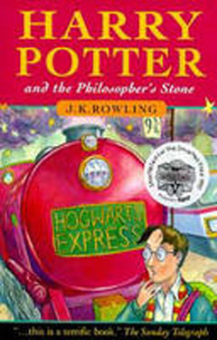
Exercise Six
Below is an extract from ‘Harry Potter and the Philosopher’s Stone’. In this extract the writer describes life for Harry Potter in the Dursley’s house.

Nearly ten years had passed since the Dursleys had woken up to find their nephew on the front step, but Privet Drive had hardly changed at all. The sun rose on the same tidy front gardens and lit up the brass number four on the Dursley’s front door; it crept into their living-room, which was almost exactly the same as it had been on the night when Mr Dursley has seen that fateful news report about the owls. Only the photographs on the mantelpiece really showed how much time had passed. Ten years ago, there had been lots of pictures of what looked like a large pink beach ball wearing different-coloured bobble hats – but Dudley Dursley was no longer a baby, and now the photographs showed a large blond boy riding his first bicycle, on the roundabout at the fair, playing a computer game with his father, being hugged and kissed by his mother. The room held no sign at all that another boy lived in the house, too.
Yet Harry potter was still there, asleep at the moment, but not for long. His Aunt Petunia was awake and it was her shrill voice which made the first noise of the day.
“Up! Get up! Now!
Harry woke with a start. His aunt rapped on the door again.
“Up!” she screeched. Harry heard her walking towards the kitchen and then the sound of the frying pan being put on the cooker. He rolled on to his back and tried to remember the dream he had been having. It had been a good one. There had been a flying motorbike in it. He had a funny feeling he’d had the same dream before.

Questions
(1a) What impression do you get of Privet Drive from the author’s description of it? (2)
(1b) Pick out an expression as evidence. (1)
(2) ‘Ten years ago, there had been lots of pictures…’
This sentence is extremely long. Give a reason why the writer chose to use such along sentence here. (2)
(3a) To what is Dudley Dursley compared? (1)
(3b) Name the technique used and explain why it is effective. (2)
(4) In your own words explain how Dudley is treated by his parents. (2)
(5a) How is Harry Potter treated? (2)
(5b) Pick out an expression as evidence. (1)
(6a) ‘Up! Get up! Now!’
Name the piece of punctuation that has been used here. (1)
(6b) Explain why you think it has been used. (2)
(7) Pick out one word that tells you that Aunt Petunia’s voice was not pleasant. (1)
(8) The writer describes a dream that Harry had been having when he was awoken. Comment on the structure of the sentences that describe his dream. Explain why you think they have been written this way. (2)
(9) Find out the meaning of: shrill (1)


Exercise Seven

Below is an extract from ‘Underground to Canada’. In this extract the main character Julilly. It tells the story of how Julilly and her friend escape from slavery on a Mississippi plantation and head northward to Canada.
The Wagon of slave children jogged slowly down the road. The clang of the chained men behind it took up a rhythm. To Julilly, it was a slow, sad rhythm – sad as the bells tolling a death from the village church near Massa Hensen’s.
Juililly could think only of Mammy Sally. Each time the cart turned into a new road, she expected to see the tall strong woman with the black head-rag come to take her from the wagon and direct the slaves to turn around and go back to Massa Hensen’s. But each new road was empty.
The little children around her wore skimpy clothes. They pressed against Julilly with their hot, dry skin and whimpered like tiny, forgotten sheep. Juililly held two, small hands, both sticky with sweat and dust.
The sun flamed gold and blistering above them, and the sky became hard and bright blue. There wasn’t a wisp of cloud to soften it. Julilly saw the white man who drove their wagon wipe his forehead with a large blue cloth. The brim of his hat hid his face, but his neck was red with sunburn. He cracked his whip over the plodding horse. The fat, oily man behind them snapped his whip over the backs of Ben and Adam and Lester who shuttled along with their chains.
The cart jogged past green cotton fields and spreading tobacco plants. Slaves chopped along the rows with their hoes, just as at Master Hensen’s. Julilly wondered if they would stop in one of these fields. Why did they go on and on? Where was the “Deep South” she heard the slave traders mumbling about?

Questions
(1a) What is the mood or the tone at the beginning of the passage? (1)
(1b) Pick out an expression as evidence. (1)
(2a) The writer tells us that ‘Julilly could think only of Mamma Sally’. What kind of person do you think Mamma Sally might be? (2)
(2b) Give a reason for your answer. (2)
(3) How are the children dressed? Choose the most suitable option:
(A) In heavy clothes (B) In new clothes (C) In light clothes (1)
(4a) Pick out the example of figurative language used to describe how the children are feeling. (2)
(4b)Explain why it is effective. (2)
(5) Give two pieces of information that suggests that the children have been travelling for some time. (2)
(6)In your own words describe what the weather was like that day. (2)
(7) The travellers enjoyed the sunshine.

TRUE | FALSE | CANNOT TELL
(2)
(7b) Give a reason for your answer. (2)
(8) What is the attitude of the fat, oily man towards the slaves? Choose the most suitable option. (A) Kind (B) Cruel (C) Sympathetic (1)
(9) Find out the meanings of: skimpy, whimpered and blistering (3)


Exercise Eight
Below is an extract from Gowie Corby Plays Chicken’. The novel tells the story of a boy called Gowie who is always getting into trouble at school. In this extract he meets his new teacher Miss Plum and has an argument with a girl called Heather.

“My name is Miss Plum,” she addresses the rest of the class, and waits for a moment, but there isn’t a flicker of a whisper or laugh, nudge, nudge.
“I hope we shall have a pleasant year together and do some interesting things,”she goes on, and yes, miss, they all chorus like sheep bleating, baa, baa, baa, the creeps. I jab the underside of the table with my knife. She hands out cardboard.
“First, I should like you all to make folders to keep your work in, and record cards to record what you have been doing. You may decorate the folders if you wish, with a suitable picture or pattern, and remember to write your names clearly.”
Soon we are all scribbling like crazy. I borrow Heather’s new felt tips and draw bombs, machine guns and swastikas over mine, together with my sign, the vampire. It looks very nice and cosy when finished, so I sit and admire it, adding a few finishing touched from time to time. The teeth, with blood oozing, are particularly good. The buzzer goes for play and we surge back to our own classroom area, where Heather bears down on me like a female hippo with weight problems and offers me a pink biscuit.
“No, thanks, it’s contaminated,” I refuse it, and then she, suddenly, for no reason at all, shouts wildly at me, her chin wobbling, popping eyes glaring at me through her tatty hair, like an old English sheepdog with rabies.
“Why are you such a mean boy, Gowie Corby? What makes you so mean? Why, you are the meanest boy in the class, the meanest boy in the school, the meanest boy in the world!”
This takes me by surprise, I don’t know why she’s getting at me, and so I mimic her wet, drippy, draggy, grotty, spew-making voice, except it’s impossible to make it bad enough.

Questions
(1) Why do you think the teacher waits for a second after she introduces herself to the class? (2)
(2) How does most of the class respond to Miss Plum? (1)
(3) In your own words explain how Gowie Corby feels about their response. (2)
(4a) Gowie draws ‘bombs, machine guns and swastikas’ over his folder. Which word best describes the kind of person Gowie Corby seems to be:
(A) Gentle (B) Violent (C) Quiet (1)
(4b) Give a reason for your answer. (2)
(5)What word used in paragraph four describes how all the children moved together when the bell goes. (1)
(6a) Pick out an example of figurative language that Gowie uses to describe Heather. (2)
(6b) Explain what image or picture it gives you of her. (2)
(7) What does the word ‘contaminated’ mean? Choose from one of the following options: (A) Horrible (B) Polluted (C) Mouldy (1)
(8) In paragraph six Heather asks Gowie “Why are you the meanest boy in the class, the meanest boy in the school, the meanest boy in the world!” Explain why you think Heather repeats the word ‘meanest’ so many times. (2)
(9) Find out the meanings of: flicker, oozing and bears down. (3)

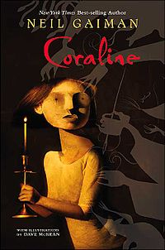
Exercise Nine
Below is an extract from ‘Coraline’. It tells the story of a girl called who finds a secret corridor behind a locked door.
Coraline was woken by the mid-morning sun, full on her face.
For a moment she felt utterly dislocated. She did not know where she was; she was not entirely sure who she was. It is astonishing just how much of what we are can be tied to the beds we wake up in the morning, and it is astonishing how fragile that can be.
Sometimes Coraline would forget who she was while she was daydreaming that she was exploring the Arctic, or the Amazon rainforest, or darkest Africa, and it was not until someone tapped her on the shoulder or said her name that Coraline would come back from a million miles away with a start, and all in a fraction of a second have to remember who she was, and what her name was, and that she was even there at all.
Now there was sun on her face, and she was Coraline Jones. Yes. And then the green and pinkness of the room she was in, and the rustling of a large painted paper butterfly as it fluttered and beat its way about the ceiling, told her where she had woken up.
She climbed out of the bed. She could not wear her pyjamas, dressing gown and slippers during the day, she decided, even if it meant wearing the other Coraline’s clothes. (Was there another Coraline? No, she decided, there wasn’t. There was just her.) There were no proper clothes in the cupboard, though.

Questions
(1) What woke Coraline up? (1)
(2) What word in paragraph one means something similar to ‘confused’? (1)
(3a) What impression do you get of the type of girl Coraline seems to be? (2)
(3b) Give a reason for your answer. (2)
(4) How is Coraline usually awoken from her daze? (2)
(5a)Pick out an example of an example of figurative language used in paragraph four. (2)
(5b) Why is it effective? (2)
(6) In paragraph five the author uses brackets. Give a reason why you think they have been used. (2)
(7) Find out the meanings of the following words: dislocated, astonishing, fragile and fraction. (4)

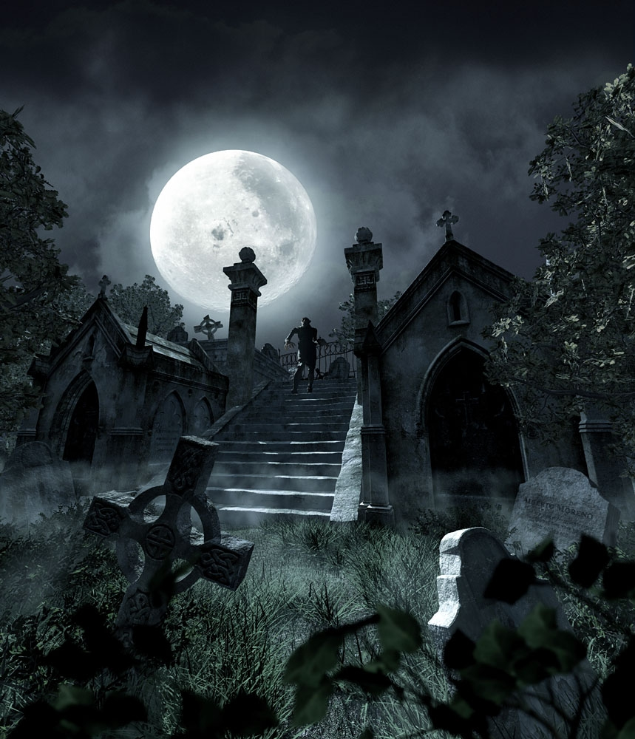
Exercise Ten
Below is an extract from ‘Whispers in the Graveyard’. It tells the story of a boy named Solomon who discovers an evil force at work in the local graveyard where he likes to go to spend time by himself.

I’m running. My chest is tight and sore. Breath rasping and whistling in my lungs. Branches whip against my face. Brambles tear at my legs and arms. There is a voice screaming. Out loud. The sound ripping through the trees, screaming and screaming.
It’s my voice.
‘Amy! Amy!’
Now I’m at the back dyke and the solid wooden fencing has been torn aside. Blasted apart as if some careless giant had passed by and trodden on it. I stare at the wood, not splintered or broken, but melted. Dissolved and warped. Curled aside to make a small space. Space enough for a child to walk through. What could do that? What power is there that would leave that mark?
I hesitate, feeling the first great lurch of fear for myself.
‘Amy?’ I cry out.
Beyond me the gaping dark of the cemetery.
There is a soft shudder in my head. A strange flicker which fastens on my fear. Nothing calling for me this time. No whispers in my face tonight.
Why?
Because Amy is in there. With one child captive, there is no need for two.

Questions
(1a) What do you notice about the sentences in the opening paragraph? (1)
(1b) Suggest a reason why they have been written like this. (2)
(2) Explain in your own words what is happening in paragraph one. (2)
(3)How would you describe the mood at the beginning of the passage. (2)
(4) There are a few different examples of figurative language used in the first paragraph. Identify two and explain why they are effective. (4)
(5) Pick out an expression that tells you that the fence is completely destroyed. (1)
(6) What is unusual about the destruction of the fence? (1)
(7) Pick out one word from the passage that means the same as to break up into pieces and disintegrate. (1)
(8) Find out the meanings of: rasping, splintered, warped, dissolved, lurch, gaping and captive. (7)
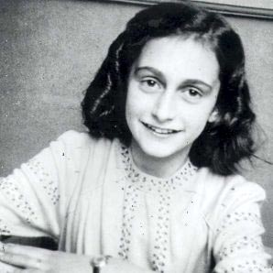
Section B – Non-Fiction

Exercise Eleven
Below is an extract from ‘The Diary of Anne frank’. It tells the story of a Jewish girl and her family who have to go into hiding for over two years after Hitler and the Nazi Party come to power.

The Diary of Anne Frank – Close Reading
Below is an extract from the actual diary of Anne Frank. Read the extract carefully and answer the following questions.

Friday, 9th October 1942

Dear Kitty,
I’ve only got dismal and depressing news for you today. Our many Jewish friends are being taken away by the dozen. These people are treated by the Gestapo without a shred of decency, being loaded into cattle trucks and sent to Westerbork, the big Jewish camp in Drente. Westerbork sounds terrible: only one washing cubicle for a hundred people and not nearly enough lavatories. There is no separate accommodation. Men, women, and children all sleep together. One hears of frightful immorality because of this; and a lot of the women, and even girls, who stay there any length of time are expecting babies.
It is impossible to escape; most of the people in the camp are branded as inmates by their shaven heads and many also by their Jewish appearance.
If it is as bad as this in Holland whatever will it be like in the distant and barbarous regions they are sent to? We assume that most of them are murdered. The British radio speaks of their being gassed.
Perhaps that is the quickest way to die. I feel terribly upset. I couldn’t tear myself away while Miep told these dreadful stories; and she herself was equally wound up for that matter. The poor thing was terrified by the guns that were shooting at British aeroplanes overhead, and by the glaring beams of the searchlights. The Germans strike without the slightest mercy. Elli too is very quiet: her boyfriend has got to go to Germany. She is afraid that the airmen who fly over our homes will drop their bombs, often weighing a million kilos, on Dirk’s head. If they stop at a small station en route, sometimes some of them manages to get out unnoticed and escape; perhaps a few manage it. This, however, is not the end of my bad news. Have you ever heard of hostages? That’s the latest thing in penalties for sabotage. Can you imagine anything so dreadful?
Prominent citizens – innocent people- are thrown into prison to await their fate. If the saboteur can’t be traced, the Gestapo simply put about five hostages against the wall. Announcements of their deaths appear in the papers frequently. These outrages are described as ‘fatal accidents’. Nice people, the Germans! To think that I was once one of them too! No, Hitler took away out nationality long ago. In fact, Germans and Jews are the greatest enemies in the world.
Yours, Anne

Questions
- Explain in your own words why does Anne feel upset on this particular day? (2)
- Pick out two words from paragraph one that tells you that Anne is upset. (2)
- Pick out a word from paragraph one which tells you that Anne disapproves of some of the behaviour in the accommodation that Jew are being taken to. (1)
- In your own words explain how the Jewish prisoners at the camps look. (2)
- In paragraph three Anne describes the other places that Jews are sent to as ‘barbarous’. Which word is closest in meaning to ‘barbarous’?
(A) Far away (B) uncivilized (C) cold (1)
- How are the Nazis killing a lot of Jews? (1)
- In your own words explain how some of the boys who have to go to Germany to fight with the Nazis manage to escape. (2)
- Pick out a word from paragraph four which means to secretly and deliberately try to ruin something. (1)
- Look at your answer to question 8. Pick out a word from paragraph five which means someone who carries out this kind of behaviour. (1)
- Pick out a phrase from paragraph five that means that some well known Jews have been sent to prison. (1)
- Explain in your own words what happens if the Gestapo cannot find out the information they want. (2)
- Find out the meaning of: cubicle, immorality, barbarous, en route, prominent and sabotage. (6)


Exercise Twelve
Below is an extract from a book called ‘Great White Sharks’. The extract below tells of some stories or legends about sharks.
Sharks were regarded as powerful beings by Pacific Islanders and were revered or worshipped by many island cultures. In the Trobriand Islands, any teenage boy who single-handedly caught a large shark and presented it to the king was greatly honoured. In the Kingdom of Tonga, legends tell of Hina, a young woman who became a shark. There are legends of fierce Tongan warriors who turned into sharks, swam to neighbouring islands, and then regained their human form to kill their enemies. Polynesian legends tell of the shark-god Kauhuhu, who lived in a huge sea cavern. The son of Fiji’s chief god was a great shark named Dekuwaqa, who also lived in a sea cave. Dekuwaqua was also once called Daucina – giver of light. His body would light up to guide Fijian war canoes on night- time raids. In some of the Solomon Islands, sharks were worshipped as friendly gods, and pigs were sacrificed to them. On the other islands, villagers believed that sharks were spirits of their ancestors. Legends on these islands tell of sharks that rescued shipwrecked fishermen and children who fell from their parents’ canoes. Eating shark flesh is still forbidden in both Solomon and Fiji Islands.
Long ago, Hawaiians believed in mano-kanaka, sharks that could become humans. Even today, villagers on the island of Pa’ama, in Vanuatu, believe that local sorcerers can change themselves into sharks. Shark worship is still practised on many islands of the Pacific Ocean.

Questions
(1) Pick out one word from the first paragraph that means that sharks were held in very high regard.
(2) Quote an expression that tells you that those who caught sharks by themselves were rewarded.
(3) In your own words describe what the Tongan warriors could do.
(4) What does the name ‘Daucinia’ mean?
(5) How are sharks viewed in some of the Solomon Islands?
(6) In your own words explain how they viewed on some other islands?
(7) What word that is repeated throughout the passage tells you that a lot of the stories about sharks are not true?
(8) Explain in your own words why you think so many islands still worship sharks?
(9) Find out the meanings of: revered, regained, legends, sacrificed and sorcerers.
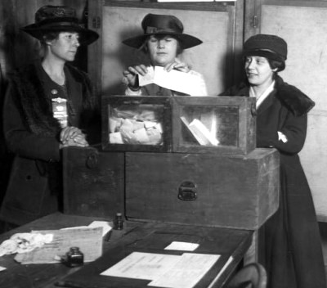
Exercise Thirteen
Below is an extract from ‘Votes for Women’. It tells the story of women know as ‘suffragettes’ like Sylvia Pankhurst, who fought for women to be allowed to vote.

At the beginning of 1907 the leaders of the suffrage societies combined to organize an open-air procession through the streets of London. They wanted to demonstrate mass support for votes for women, and in spite of heavy rain about 4,000 people turned out for it.
The march was later called the Mud March because of the weather that day. It might not sound important or even memorable that it was raining that day and that the streets were muddy. But if you were a middle-class or upper-class woman marching in 1907 you would be wearing a long skirt-long enough to touch the ground. Most women marchers ended up with soaked and muddy skirts that day. (Younger women, like Sylvia Pankhurst, wore skirts that were shorter and came just above their ankles. They wanted to be able to move easily, walk fast, and show they didn’t support the old ways. Working-class women and especially household servants also wore shorter skirts. If their skirts had touched the ground they’d never have been able to carry things up and down stairs without tripping, as they needed to do in their jobs.)

Questions
(1) In your own words explain what happened at the beginning of 1907.
(2) Explain the purpose of it.
(3) Who was responsible for organizing the march?
(4) Pick out an expression that shows that there was a lot of support for this cause.
(5) Why do you think the writer has used to phrase ‘in spite of heavy rain…’ ?
(6) What happened on that day that made it particularly memorable?
(7) What identified women as being from a middle or upper-class background?
(8) Explain in your own words why working class women wore shorter skirts.
(9) At the end of the extract the writer uses brackets. Explain why you think they have been used.
(10) Find the meanings of: suffrage, procession and demonstrate.
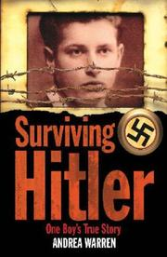
Exercise Fourteen
Below is an extract from ‘Surviving Hitler’. It tells the true story of a fifteen- year- old boy who survived one of Hitler’s concentration camps.
“We staggered through the blows from the guards,” Jack remembered. “They barked at us to line up in rows of five. We stood silent, with our heads down. The officer in charge told us we were now prisoners of Hitler’s SS special forces, and were in Blechhammer concentration camp in Germany. We had no rights. The only right we had was to die.”
Jack and the others were taken to a room where they were ordered to undress and then form lines. Camp prisoners, who were not allowed to speak to the new prisoners, roughly shaved off all their hair to prevent lice. Jack touched his newly shaved scalp. His hair was only three-quarters of an inch long and had a stripe through the middle, shaved right down to the skin, to mark him as a concentration camp prisoner.
Next, he had to stand still while his skin was coated with a chemical disinfectant to kill lice. He had to bite his lip and force himself not to cry out, so badly did the solution burn. Around him, men screamed in pain.
Uniforms were tossed to them, and Jack quickly put his on. It looked like that worn by every other prisoner – coarse cotton with blue and grey stripes. He had no underwear or socks, but at least the uniform had pockets. On the front left was a number: 16013. This meant 16,012 prisoners had been processed into this camp before Jack. From now on, no matter which camp he was in, the number 16013 would be his identification. As far as the Nazis were concerned, he no longer had a name.
Questions
(1) What do you think the purpose of this piece of literature is?
(2) The writer says ‘The only right we had was to die.’ Why does the writer use italics here?
(3) What did the guards do to the prisoners so that they would be easily identified as being camp prisoners?
(4) Quote an expression that describes how the men felt when they were disinfected.
(5) Comment on the use of the dash in the final paragraph. Why is it used?
(6)What does the word ‘coarse’ mean? Choose one answer from the following: (A) heavy (B) dirty (C) rough
(7) What is the overall mood of the passage? Give a reason for your answer.
(8)Explain in your own words why the writer feels that ‘he no longer had a name’.
(9)Find out the meanings of: staggered, solution, processed and coarse.

Exercise Fifteen
Below is an extract from ‘Chinese Cinderella’. It tells the true story of a young Chinese girl whose mother dies giving birth to her. This means that she is considered to be bad luck and is sent away and rejected by her family. The book tells of her struggle for acceptance.
Day after dreary day went by. New Year came and it was 1949. There was nobody to play with and nothing to do. The sisters were far too worried and preoccupied to fuss with me. Every day was a free day. I spent a lot of time in the library reading fairy-tales. Mother Marie had given me a book for Christmas called Paper Magic (Playing Solitary Games with Paper: Origami and Paper Cuts). Hour after hour, I learned how to fold and cut paper into aeroplanes, ships, flowers, monkeys and birds. I loved this book because my troubles seemed to vanish when I applied its magic.
I didn’t dare ask Mother Marie too often whether I had any mail because the answer was always no. I didn’t know then that Niang had instructed the nuns to stop all my incoming and outgoing mail and forward it all to her instead.
‘Look, there is no point inquiring any more!’ she told me one day. ‘Believe me, if you get a letter, I’ll shout it from the rooftop and bring it to you at once! Even if you are asleep I’ll wake you up!’
Then she looked embarrassed and gave me a piece of candy which she took from a small gold box in her pocket. ‘This little snuff box is the only thing I have to remind me of my father, ‘she told me. ‘He died in Nimes three years ago. So you see, we all suffer in one way or another…Let us pray for each other.’ In her voice I heard sadness and fear.

Questions
(1a) Comment on the opening sentences of the passage. What do you notice about the length of the sentences?
(1b) What is the effect of this?
(2) The sisters at the school spend a lot of time with the girl. TRUE or FALSE. Give a reason for your answer.
(3) The writer says ‘Every day was a free day’. Is she happy or sad about this? Explain your answer.
(4) Explain in your own words why she loves the book that Sister Marie gives her.
(5) Why does the girl not receive any mail?
(6) ‘Look, there is no point inquiring any more!’ Comment on the punctuation used in this sentence and the sentences that follow.
(7) After the nun says this she ‘looked embarrassed’. Explain why she might feel this way.
(8) ‘In her voice I heard sadness and fear’. Explain why this might be so.
(9) Find out the meanings of: preoccupied, incoming, outgoing, inquiring and instructed.

Exercise Sixteen
Below is an extract from ‘Long Walk to Freedom’which is the autobiography for Nelson Mandela. He struggled to free black Africans from the injustices of apartheid and was imprisoned for 27 years. When he was released he was elected as president of South Africa and apartheid was abolished.
We were awakened at 5.30 each morning by the night warder, who clanged a brass bell at the head of our corridor and yelled, ‘Word wakker! Staan op!’ (Wake up! Get!) I have always been an early riser and this hour was not a burden to me. Although we were roused at 5.30, we were not let out of our cells until 6.45, by which time we were meant to have cleaned our cells and rolled up our mats and blankets. We had no running water in our cells and instead of toilets had sanitary buckets known as ‘ballies’. The ballies had a diameter of ten inches with a concave porcelain lid on top that could contain water. The water in this lid was meant to be used for shaving and to clean our hands and faces.
At 6.45, when we were let out of our cells, the first thing we did was to empty our ballies. The ballies. The ballies had to be thoroughly cleansed in the sinks at the end of the corridor or they created a stench. The only pleasant thing about cleaning one’s ballie was that this was the one moment in those early days when we could have a whispered word with our colleagues. The warders did not like to linger when we cleaned them, so it was a chance to talk softly.
During those first few months, breakfast was delivered to us in our cells by prisoners from the general section. Breakfast consisted of mealie pap porridge, cereal made from maize or corn, which the general prisoners would slop in a bowl and then spin through the bars of our cells. It was a clever trick and required a deft hand so as not to spill any of the porridge.
Questions
(1a) Pick out a an example of figurative language used in the first sentence.
(1b) Explain why it is effective.
(2) Explain the use of the brackets in the first paragraph.
(3) Pick out an expression that tells you that getting up early was not difficult for Nelson Mandela.
(4) Nelson Mandela writes that the ballies had to be thoroughly cleansed or they would create a ‘stench’. Why do you think he uses this word rather than just saying that they would smell?
(5) What were the two main uses of the ‘ballies’?
(6) What was the one thing that Nelson Mandela enjoyed about cleaning the ballie?
(7) Pick out one word from the final paragraph that means ‘made up of’.
(8) What does the word ‘deft’ mean? Choose one of the following options: (A) small (B) careful (C) skilful
(9) Find out the meanings of: burden, colleagues, linger and deft.

Exercise Seventeen
Below is an extract from ‘Wild Swans’. It tells the true story of three generations of women living in Communist China.

These houses were built to cope with the extremes of a brutally harsh climate, which lurched from freezing winters to scorching summers, with virtually no spring or autumn in between. In summer, the temperature could rise above 95 degrees, but in winter it fell to minus 20 degrees, with howling winds, which roared down from Siberia across the plains. Dust tore into the eyes and bit into the skin for much of the year, and people often had to wear masks which covered their entire faces and heads. In the inner courtyard of the houses, all the windows in the main rooms opened to the south to let in as much sunshine as possible, while the walls on the north side took the brunt of the wind and the dust. The north side of the house contained a sitting room and my grandmother’s chamber; the wings on the two sides were for the servants and for all other activities. The floors of the main rooms were tiled, while the wooden windows were covered with paper. The pitched roof was made of smooth black tiles.
The house was luxurious by local standards – and far superior to her parents’ home – but my grandmother was lonely and miserable. There were several servants, including a doorkeeper, a cook, and two maids. Their task was not only to serve but also to act as guards and spies. The doorkeeper was under instructions not to let my grandmother out alone under any circumstances.

Questions
(1) In your own words explain the changes in the weather that the author describes in the first two sentences.
(2) Pick out an expression which describes how ferocious the weather could get.
(3a) Name the technique that the writer uses to describe the ferocious weather.
(3b) Explain why it is effective.
(4) Pick out two individual words that describe the physical affect that this extreme weather had on the body.
(5) How did people try to protect themselves from the weather?
(6) In your own words describe the house that is mentioned.
(7) Comment on the use of the dashes at the beginning of the second paragraph.
(8) Find out the meanings of: virtually, chamber, pitched and superior.

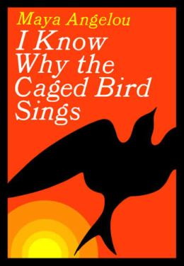
Exercise Eighteen
Below is an extract from ‘I Know Why the caged Bird Sings’. In it Maya Angelou describes her childhood with her grandmother in the American south of the 1930s.
One Christmas we received gifts from our mother and father, who lived separately in a heaven called California, where we were told they could have all the oranges they could eat. And the sun shone all the time. I was sure that wasn’t so. I couldn’t believe that our mother would laugh and eat oranges in the sunshine without her children. Until that Christmas when we received the gifts I had been confident that they were both dead. I could cry anytime I wanted by picturing my mother (I didn’t quite know what she looked like) lying in her coffin. Her hair, which was black, was spread out on a tiny little white pillow and her body was covered with a sheet. The face was brown like a big O, and since I couldn’t fill in the features I printed MOTHER across the O, and tears would fall down my cheeks like warm milk.
Then came that terrible Christmas with its awful presents when our father, with the vanity I was to find typical, sent his photograph. My gift from Mother was a tea set – a teapot, four cups and saucers and tiny spoons – and a doll with blue eyes and rosy cheeks and yellow hair painted on her head. I didn’t know what Bailey received, but after I opened my boxes I went out to the backyard behind the chinaberry tree. The day was cold and the air as clear as water. Frost was still on the bench but I sat down and cried. I looked up and Bailey was coming from the outhouse, wiping his eyes. He had been crying too. I didn’t know if he has also told himself they were dead and had been rudely awakened to the truth or whether he was just feeling lonely. The gifts opened the door to questions that neither of us wanted to ask. Why did they send us away? and What did we do wrong? So Wrong?

Questions
(1) Explain why the writer calls California a ‘heaven’.
(2) Explain in your own words why the writer finds it hard to believe that her mother lives there.
(3) Why did the writer believe that her parents were dead?
(4) The writer describes her mother’s face as being ‘like a big O’. Why does she describe it like this?
(5)What two reasons does the author suggest for her brother’s tears?
(6) What does the author remember about the weather on that particular day?
(7) Explain in your own words the effect that the presents from their parents have on the children.
(8) Find out the meanings of: vanity, outhouse and typical.

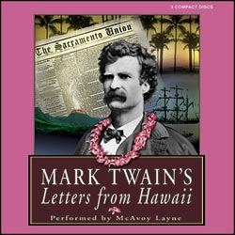
Exercise Nineteen
Below is an extract from ‘Letters from Hawaii’ by Mark Twain. Below is an extract from a letter that he wrote in 1866 about an uncomfortable sightseeing ride to Diamond Head, which is an extinct volcano.
I am probably the most sensitive man in the kingdom of Hawaii tonight – especially about sitting down in the presence of my betters. I have ridden fifteen or twenty miles on horseback since 5pm, and to tell the honest truth, I have a delicacy about sitting down at all. I am one of the poorest horsemen in the world, and I never mount a horse without experiencing a sort of dread that I may be setting out on that last mysterious journey which all of us must take sooner or later, and I never come back in safety from a horseback trip without thinking my latter end for two or three days afterward. This same old regular devotional sentiment began just as soon as I sat down here five minutes ago.
An excursion to Diamond Head and the King’s Coconut Grove was planned today – time, 4.30 pm, - the party to consist of half a dozen gentlemen and three ladies. They all started at the appointed hour except myself. I was at the government prison, and got so interested in its examination that I did not notice how quickly the time was passing. Someone remarked that it was twenty minutes past five o’clock, and that woke me up. It was a fortunate circumstance that Captain Phillips was there with his ‘turnout’, as he calls a top buggy that Captain Cook brought here in 1778, and a horse that was here when Captain Cook came. Captain Phillips takes a just pride in his driving and in the speed of his horse, and to his passion for displaying them I owe it that we were only sixteen minutes coming from the prison to the American Hotel – a distance which has been estimated to be over half a mile.

Questions
(1) Explain in your own words why the writer says that he is ‘the most sensitive men in the kingdom’.
(2) Why does the writer dread journeys on horseback?
(3) Pick out an expression as evidence.
(4) Who else does the writer go on to trip with?
(5) Why does the writer not leave for the excursion at the same time as the others?
(6) How does he get back to the hotel he is staying at?
(7) Why is the dash used in the last line of the passage?
(8)Find out the meanings of: delicacy, latter, devotional, sentiment, excursion and estimated.
Exercise Twenty
Below is an extract from ‘I Know Why the Caged Bird Sings’. In this extract the writer remembers spending the night in an old abandoned car in a junkyard.
I spent the day wandering aimlessly through the bright streets. The noisy penny arcades with their gaggle-giggle of sailors and children and the games of chance were tempting, but after walking through one of them it was obvious that I could only win more chances and no money. I went to the library and used a part of my day reading science fiction, and in its marble washroom I changed my bandage.
On one flat street I passed a junkyard, littered with the carcasses of old cars. The dead hulks were somehow so uninviting that I decided to inspect them. As I wound my way through the discards a temporary solution sprang to my mind. I would find a clean or cleanish car and spend the night in it. With the optimism of ignorance I thought that the morning was bound to bring a more pleasant solution. A tall-bodied grey car near the fence caught my eye. Its seats were untorn, and although it had no wheels or rims it sat evenly on its fenders. The idea of sleeping in the near open bolstered my sense of freedom. I was a loose kite in a gentle wind floating with only my will for an anchor. After deciding upon the car, I got inside and ate the tuna sandwiches and then searched the floorboards for holes. The fear that rats might scurry in and eat off my nose as I slept (some case had been recently reported in the papers) was more alarming than the shadowed hulks in the junkyard or the quickly descending night. My grey choice, however, seemed rat-tight, and I abandoned my idea of taking another walk and decided to sit steady and wait for sleep.

Questions
(1) Pick out one word from the beginning of the passage that tells you that the author had no definite plans that day.
(2) In your own words describe the kind of place that she wanders around.
(3) Quote an expression that helps to describe the scene.
(4) The author describes the junkyard as being ‘littered with the carcasses of old cars’. Name the an example of figurative language used here and explain why it is effective.
(5) Explain in your own words why she decides to go and look more closely at the old cars.
(6)What does the word ‘temporary’ mean? Choose from the following options: (A) Good (B) Short-term (C) Safe
(7)How does the author decide which car to choose to sleep in?
(8) The writer says ‘I was a loose kite in a gentle wind floating with only my will for an anchor’. Name the imagery used and explain why it is effective.
(9) What is the writer’s main concern as she gets into the car?
(10) Find out the meanings of: carcasses, hulks, uninviting, discards, temporary, optimism, fenders and bolstered.

