Linwood High School – Ground Floor – Entry Point for New S1

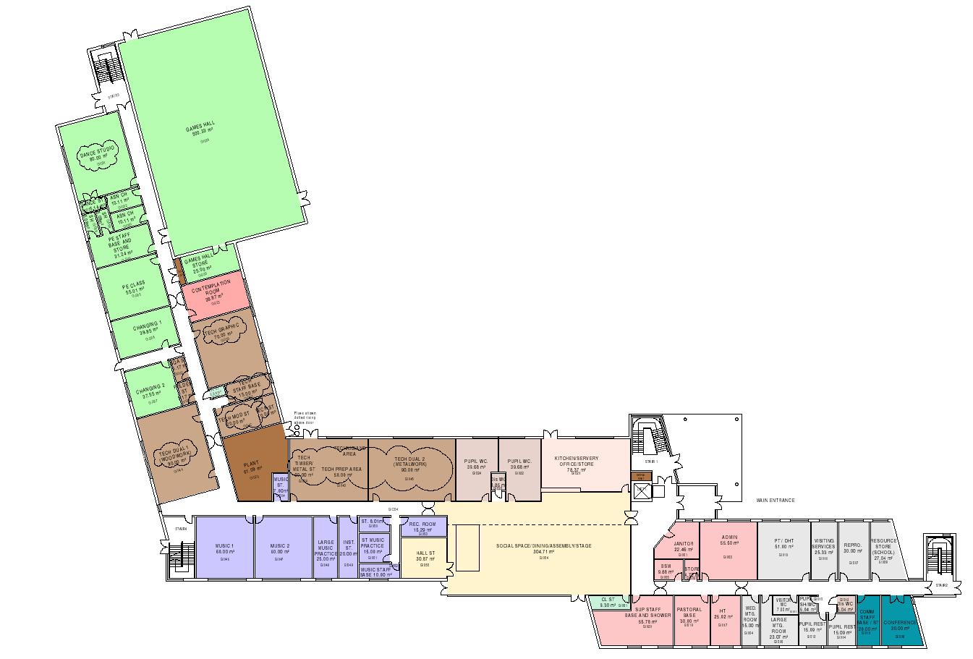
S1 Meeting Point
PUPIL GATES
Please enter via pedestrian gate entrance on Stirling Drive.
Follow the signage and take the walkway to your left once through the gates.
Follow the signage to the entrance marked.

