Tel: | 0300 300 0300
My Ref: | SQ/KO
Your Ref:
Contact: | Steven Quinn
E-mail: | steven.quinn@renfrewshire.gov.uk
Date: | 23 March 2020
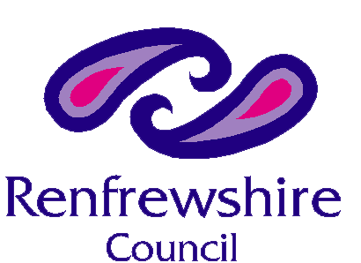

Dear Parent or Carer of a child in S4-S6

Over the weekend, guidelines have changed significantly including the announcement that all S4-S6 pupils should remain at home. This now means that all children and young people should not attend school with the exception of those children whose parents/ carers are key workers and have no alternative childcare facilities.

I understand the concern this will be causing your child and at this time. However, we must make sure that the welfare of our young people, our staff and our communities is the absolute priority.

Nevertheless, I want to reassure you that we will continue to do everything possible to support our young people in the weeks and months ahead.

I fully recognise the anxiety that this will cause around the uncertainty of national qualification grades that your child has been working towards. Although I am unable to offer any certainty around this at this time, I can offer you a guarantee that all staff in Renfrewshire are continuing to work through these challenges to ensure we deliver the best outcomes possible for your child.

Your child’s school will be in touch as soon as possible to offer greater clarity on the arrangements that we will put in place to give the supports required. We will work closely with SQA to ensure we are following all advice to best support your child to gain the grades that their work throughout the year merits.

In the meantime, can I once again offer my sincere thanks for your patience and continued support. It is greatly appreciated.

By working together, we will make every effort to ensure our young people are not disadvantaged.

Please look after yourselves and your family in these very challenging times.

Yours sincerely,

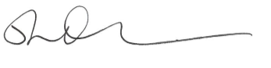

Steven Quinn
Director of Children’s Services

